

**FINAL YEAR PROJECT REPORT**

**“EASY PETROL”**

**SUBMITTED BY**

AREESHA NADEEM (12613)

AYESHA SOHAIL (12612)

**PROJECT CO-ORDINATOR**

DR. AARIJ MEHMOOD HUSSAAN

**PROJECT SUPERVISOR**

JAMAL HAIDER ZAIDI

**CHAPTER 01: INTRODUCTION**

This chapter gives an overview of the project. It explains the problem with the existing system, and need for the proposed system in current scenario. The solution to the problems and an overview of the proposed system is given.

## 1.1 **Overview**

The aim of our software is to maintain the record of the user and the rider and almost all the details related to the trip, the main task is real time tracking of the rider and the user. The user and rider can easily see the location of each other and the total amount receipt will be shown depending on the order.

1.2 **Objective**

The Fuel Provider Application is to fulfill the growing demand for conventional fuel delivery by connecting the users or customers and the fuel drivers through this application. This would be an easy way for customers to order the fuel whenever needed and can avoid long queues on the fuel station. This application can run only on Android devices. It would inform the customers about the exact time of arrival of the rider. After the confirmation of the order an alert would be sent in case of any cancelation of the order. The location of the rider and the costume are shown on dynamic maps using Google maps. The application gives the real time service and it is very helpful.

**CHAPTER 02: TECHNICAL BACKGROUND**

**2.1 DETAIL OF BASIC TECHNOLOGY**

**2.1.1 Tools**

* C#
* CSS
* FIREBASE DATABASE
* ANDROID STUDIO

**C#:**

C# syntax is highly expressive, yet it is also simple and easy to learn. The curly brace syntax of C# will be instantly recognizable to anyone familiar with C, C++, or Java. Developers who know any of these languages are typically able to begin to work productively in C# within a short time. C# syntax simplifies many of the complexities of C++ and provides powerful features such as nullable types, enumerations, delegates, lambda expressions, and direct memory access. C# supports generic methods and types, which provide increased type safety and performance, and iterators, which enable implementers of collection classes to define custom iteration behaviors that are simple to use by client code. Language-Integrated Query (LINQ) expressions make the strongly typed query a first-class language construct.

As an object-oriented language, C# supports the concepts of encapsulation, inheritance, and polymorphism. All variables and methods, including the Main method, the application's entry point, are encapsulated within class definitions. A class may inherit directly from one parent class, but it may implement any number of interfaces. Methods that override virtual methods in a parent class require the override keyword as a way to avoid accidental redefinition. In C#, a struct is like a lightweight class; it is a stack-allocated type that can implement interfaces but does not support inheritance.

In addition to these basic object-oriented principles, C# makes it easy to develop software components through several innovative language constructs, including the following:

Encapsulated method signatures called *delegates*, which enable type-safe event notifications.

Properties, which serve as accessors for private member variables.

Attributes, which provide declarative metadata about types at run time.

Inline XML documentation comments.

Language-Integrated Query (LINQ), which provides built-in query capabilities across a variety of data sources.

If you have to interact with other Windows software such as COM objects or native Win32 DLLs, you can do this in C# through a process called "Interop". Interop enables C# programs to do almost anything that a native C++ application can do. C# even supports pointers and the concept of "unsafe" code for those cases in which direct memory access is critical.

The C# build process is simple compared to C and C++ and more flexible than in Java. There are no separate header files, and no requirement that methods and types be declared in a particular order. A C# source file may define any number of classes, structs, interfaces, and events.

**CSS:**

Cascading Style Sheets, fondly referred to as CSS, is a simple design language intended to simplify the process of making web pages presentable.

CSS handles the look and feel part of a web page. Using CSS, you can control the color of the text, the style of fonts, the spacing between paragraphs, how columns are sized and laid out, what background images or colors are used, layout designs, variations in display for different devices and screen sizes as well as a variety of other effects.

CSS is easy to learn and understand but it provides powerful control over the presentation of an HTML document. Most commonly, CSS is combined with the markup languages HTML or XHTML.

## **Advantages of CSS**

CSS saves time − You can write CSS once and then reuse same sheet in multiple HTML pages. You can define a style for each HTML element and apply it to as many Web pages as you want.

Pages load faster − If you are using CSS, you do not need to write HTML tag attributes every time. Just write one CSS rule of a tag and apply it to all the occurrences of that tag. So less code means faster download times.

Easy maintenance − To make a global change, simply change the style, and all elements in all the web pages will be updated automatically.

Superior styles to HTML − CSS has a much wider array of attributes than HTML, so you can give a far better look to your HTML page in comparison to HTML attributes.

Multiple Device Compatibility − Style sheets allow content to be optimized for more than one type of device. By using the same HTML document, different versions of a website can be presented for handheld devices such as PDAs and cell phones or for printing.

Global web standards − Now HTML attributes are being deprecated and it is being recommended to use CSS. So its a good idea to start using CSS in all the HTML pages to make them compatible to future browsers.

## **Who Creates and Maintains CSS?**

CSS is created and maintained through a group of people within the W3C called the CSS Working Group. The CSS Working Group creates documents called specifications. When a specification has been discussed and officially ratified by the W3C members, it becomes a recommendation.

These ratified specifications are called recommendations because the W3C has no control over the actual implementation of the language. Independent companies and organizations create that software.

**FIREBASE:**

**Firebase** is a Backend-as-a-Service (Baas). It provides developers with a variety of tools and services to help them develop quality apps, grow their user base, and earn profit. It is built on Google’s infrastructure.

Firebase is categorized as a [NoSQL](https://www.educative.io/edpresso/whats-the-difference-betweensql-and-nosql) database program, which stores data in JSON-like documents.

## Key Features

### **Authentication:**

It supports authentication using passwords, phone numbers, Google, Facebook, Twitter, and more. The Firebase Authentication (SDK) can be used to manually integrate one or more sign-in methods into an app.

### **Realtime database:**

Data is synced across all clients in realtime and remains available even when an app goes offline.

### **Hosting:**

Firebase Hosting provides fast hosting for a web app; content is cached into content delivery networks worldwide.

### **Test lab:**

The application is tested on virtual and physical devices located in Google’s data centers.

### **Notifications:**

Notifications can be sent with firebase with no additional coding.

Users can get started with firebase for free; more details can be found on the [official website](https://firebase.google.com/).

**ANDROID STUDIO:**

Android Studio is the official integrated development environment ([IDE](https://searchsoftwarequality.techtarget.com/definition/integrated-development-environment)) for Android application development. It is based on the [IntelliJ IDEA](https://www.theserverside.com/definition/IntellJ-IDEA), a [Java](https://www.theserverside.com/definition/Java) integrated development environment for software, and incorporates its code editing and developer tools.

To support application development within the Android operating system, Android Studio uses a Gradle-based build system, [emulator](https://whatis.techtarget.com/definition/emulator), code templates, and [Github](https://searchitoperations.techtarget.com/definition/GitHub) integration. Every project in Android Studio has one or more modalities with source code and resource files. These modalities include Android app modules, Library modules, and Google App Engine modules.

Android Studio uses an Instant Push feature to push code and resource changes to a running application. A code editor assists the developer with writing code and offering code completion, refraction, and analysis. Applications built in Android Studio are then compiled into the [APK format](https://whatis.techtarget.com/definition/APK-file-Android-Package-Kit-file-format) for submission to the Google Play Store.

The software was first announced at Google I/O in May 2013, and the first stable build was released in December 2014. Android Studio is available for Mac, Windows, and Linux desktop platforms. It replaced Eclipse Android Development Tools (ADT) as the primary IDE for Android application development. Android Studio and the Software Development Kit can be downloaded [directly from Google](https://developer.android.com/studio/).

**2.2 PROBLEM DOMAIN:**

As living in a country like Pakistan there are many problems that are being faced by the people living here. The thing is that we want a solution to every problem as fast as we can. So, providing a solution to any problem would be considered as a huge achievement for anybody. Coming to the problem that is increasing rapidly on a daily basis is related to transportation, as discussing it more in detail is that the people who are using transport on a daily basis sometimes get stuck in a sudden situation like they ran out of petrol, couldn’t find a petrol pump near to their location. It has become very difficult for the people travelling and then suddenly they run out of petrol or gas and at that moment of time they are hopeless because they cannot do anything. Basically, such kind of situations occur at our homes as well, when there is no electricity and the only thing that helps us is the generator. If the generator also doesn’t work due to petrol shortage it would be difficult for us to work at our homes with no lights on. Being housewives in such crucial times it is not possible for them to go out and get petrol.

This is the most common problem that needs to be solved because travelling has become so important. People who work in big sectors or who are employees or considering a normal person travelling on the road can face this problem anytime. The solution should be so helpful that it can solve everyone’s problem regarding the lack of petrol in such situations. It should solve the basic need of any housewife who cannot go out due to some conditions and get it all online on just one click. The solution provided should make life easier for the people who travel on a daily basis.

**2.3 COMPARISION WITH OTHER SOLUTIONS:**

As we have discussed the problems above. The solutions that we will be providing will be easy for the users who will be facing this issue. As it will be easy for the user as the user do not have to go himself to the petrol pump to get the petrol. Our application will be providing the user to just order the amount of petrol he needs just within a click. This would save a lot of time of the user regardless he goes to the petrol pump and get the fuel. Our users would not have to wait in the long queues to get the petrol, as our riders will be available to do that for them.

**2.4 RESEARCH PAPER:**

1. <https://www.researchgate.net/publication/254008906_On_the_Analysis_of_Cascading_Style_Sheets>

Developing and maintaining cascading style sheets (CSS) is an important issue to web developers as they suffer from the lack of rigorous methods. Most existing means rely on validators that check syntactic rules, and on runtime debuggers that check the behavior of a CSS style sheet on a particular document instance. However, the aim of most style sheets is to be applied to an entire set of documents, usually defined by some schema. To this end, a CSS style sheet is usually written w.r.t. a given schema.

1. <https://www.researchgate.net/publication/316657119_Android_Application_Development_With_Android_Studio>

It starts by creating an Android application project for phones and tablets and continues with additional development modules for the application. Creating a new Android project is pretty straightforward with Android Studio. Android Studio helps to select the best SDK version for the application. One needs to build the application and launch it on a device after creation of the application project.

**CHAPTER 03: REQUIREMENTS AND METHODOLOGY**

**3.1 SOLUTION:**

As we have discussed the problems above. This project intends to resolve the problem for the people who need fuel or diesel on urgent basis. We will provide delivery of fuel on your given location and will keep the track by using google maps. We will be tracking the delivery person as well. This app would surely hold the potential to resolve this problem that so many people go through every day. The users would need mandatory internet connection. We will be storing all the information which connects the person and the delivery man. We will ensure that the user will get fuel on least time duration so that their problem will be solved as soon as possible.

**3.2 IMPLEMENTATION OF REQUIREMENTS USING LOGIC, CONSTRAINTS, PLATFORM AND STRATEGIES:**

The constraints that we are using in our project are as follows:

**SCOPE:**

The scope of our project is to reduce the problem that the people are facing on daily basis and to ensure them that we will be providing them an application that will sought out the problem when they will ran out of petrol or will be in the need of getting petrol.

**TIME:**

The time that was taken to complete our application was 6 months. The project delivery time was estimated according to the requirements of the project. We worked on the application which will ensure the user about the delivery time and the distance, that would be calculated. The time will be calculated upon how much is the distance between the user and the rider and how much time rider takes to reach the user.

**COST:**

We estimated the cost accordingly to the market rates for the petrol that will be provided through our application. The user will not have to pay extra charges as if they our using our services. We ensure that the cost of the petrol will be according to the market. We have estimated the budget by considering all costs, like the cost of the petrol, we will be considering the distance, we will be considering the fairs according to the events, as lets take an example of Islamic events that occur in our country and on those days the fairs are high and set according to those events.

**BENEFITS:**

There would be real time tracking of the orders that will be placed by the user, it will be easy for the user to check where is the rider and how much time is left. The user will get the notification as the rider has accepted his/her request. The user will be able to get the petrol whenever he wants.

**3.3 FEATURES:**

* Management of data.
* Live Ordering.
* Search for fuel providers (riders).
* Real Time Tracking.
* Rate and Reviews.
* Automatic Alert and Notification.

**3.4 TYPE OF ROLES:**

1. Users.

2. Riders.

3. Admin.

**3.5 REQUIREMENTS:**

**3.5.1 USER REQUIREMENTS:**

The user requirements that we have gathered from the people are as follow:

* The application must be responsive.
* The petrol should be delivered in the estimated time.
* The rider should be available.
* The rate should be calculated according to the amount of petrol that is being delivered.
* There should not be charged extra money for the service that is being provided.
* The riders must be of polite nature and should deal with the user calmly.

**3.5.2 FEATURES IN DETAIL:**

According to our features, the data of the users and the drivers will be managed by the admin and there will be surety that all the information that is provided by our users will be protected and managed properly. All the information would be kept private. The user will be able to order live whenever he/she is in the need of petrol but should have an internet connectivity. The user will be able to search for the riders and if there is no rider available at that moment so, the user has an option to click on the bykea button and avail the riders from there. There will be real time tracking of the order that the user has placed and can check where is the rider and in how much time he will arrive. Another feature is there to rate and review the application once the user has taken the order. Alert and notifications will be generated when the order is confirmed.

**3.5.3 FUNCTIONAL REQUIREMENTS:**

* We will ensure rider availability (bykea). If there is no rider available the user can switch to bykea.
* After the confirmation, till 30 secs the user would be able to cancel the request. There would be no charges that will be applied on the cancellation of the order within 30 secs.
* Time tracking of the order.
* Payment method would be cash on delivery.
* Minimum amount of petrol should be 2 liters if its less than 2 liters than some additional charges would be applied.

**3.6 NON-FUNCTIONAL REQUIREMENTS:**

* Privacy of personal information.
* Shall be responsive to the user input (Screen Adaption).
* 24/7 availability of service.
* Secure access control.
* Internet connectivity.
* Response time.
* Risk analysis.

**CHAPTER 04: PROJECT PLAN AND INITIAL DESIGN**

**4.1 PROJECT PLAN:**

As starting with the project, we planned to start working on the database first. We worked on firebase on which all the users and driver information would be saved. Then coming to the application it was hard to manage and work on two applications at a time, so as our supervisor suggested us that we should break our work into chunks and go with one application at a time. We started working on the user’s application and were done with all the implementation and development. At last, it was the driver application on which we had to work and complete that on time. Our Easy Petrol application will provide a virtual way to have an eye for providing the fuel to the people at the right time by using our mobile application, where we will keep the track of the user’s location and the rider’ location as well. This application will also provide the monitoring system according to the best flavor suited for the user. This application will update the concerns about the timing and the current location, which will be useful for the user. This application will also provide personal records of the user and rider and will check the rider availability and will exactly calculate and tell the estimated time to the user. GPS technology plays a vast role in an application through which the user would have an eye on the rider's exact position and the rider would be able to keep track of the user's current location, where the petrol needs to be delivered. It will also resolve the issue that if the rider is not available at that moment, we have added a bykea button, by clicking on that the user can switch to bykea application, to make sure that the user gets the services on time. Overall, this application is a single platform for solving issues related to the petrol that people faces on a daily basis.

**4.2 PROJECT MODULES:**

**4.2.1 DRIVER APP:**

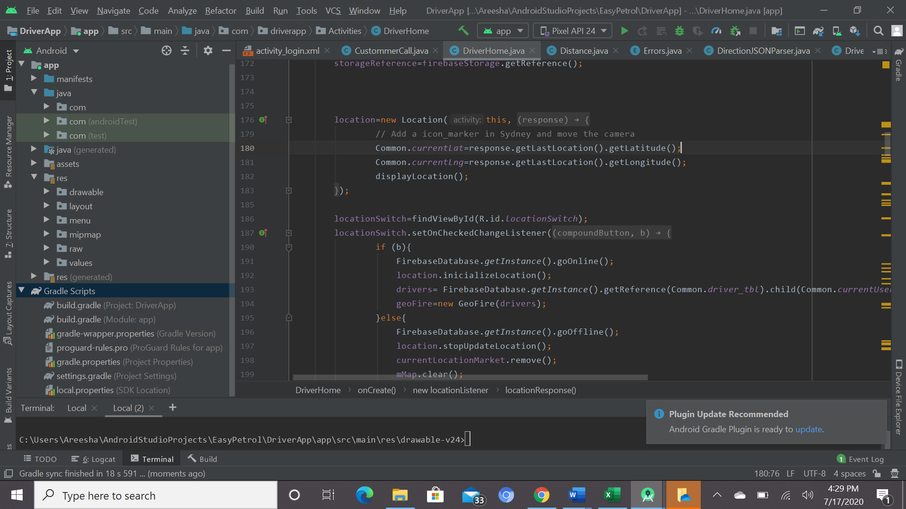

We selected the phone and tablet module. As first we worked on the diver app in which the module is named as “app” contains all the files related to the project. It includes all the code files and the android manifest files of our project. It took time to create all the code of our project as there were many things on which we had to work. We tried our best to complete the project in the given estimated time.

**4.2.2 RIDER APP:**

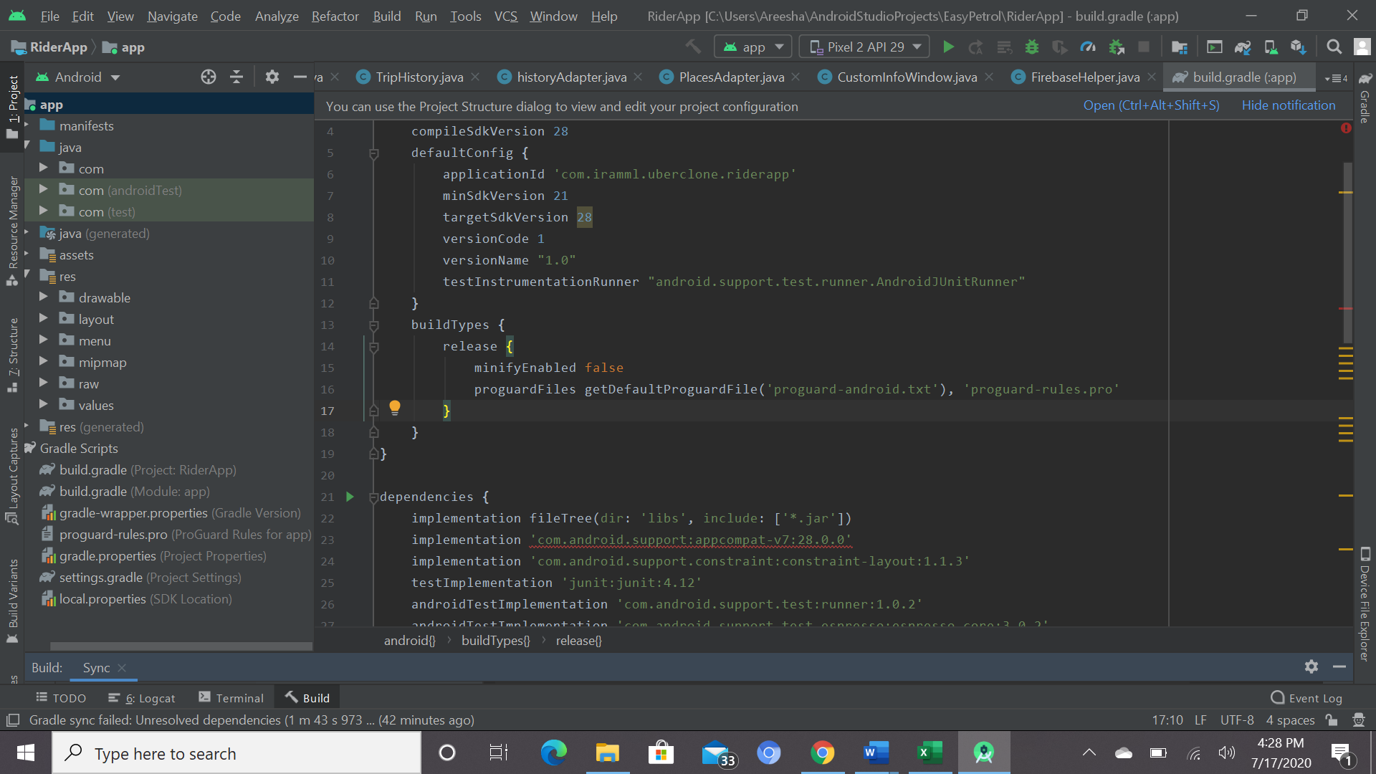

For the rider app, we selected the phone and tablet module. As working on the rider app the module, which is app, was as same as the driver app but the files and code was different. We worked on the code and different activities of the project. The layout of the project took time in which we had to do the designing of our app. There are different files and folders in the module app, which sums up all the files of our project.

**4.3 GANTT CHART:**

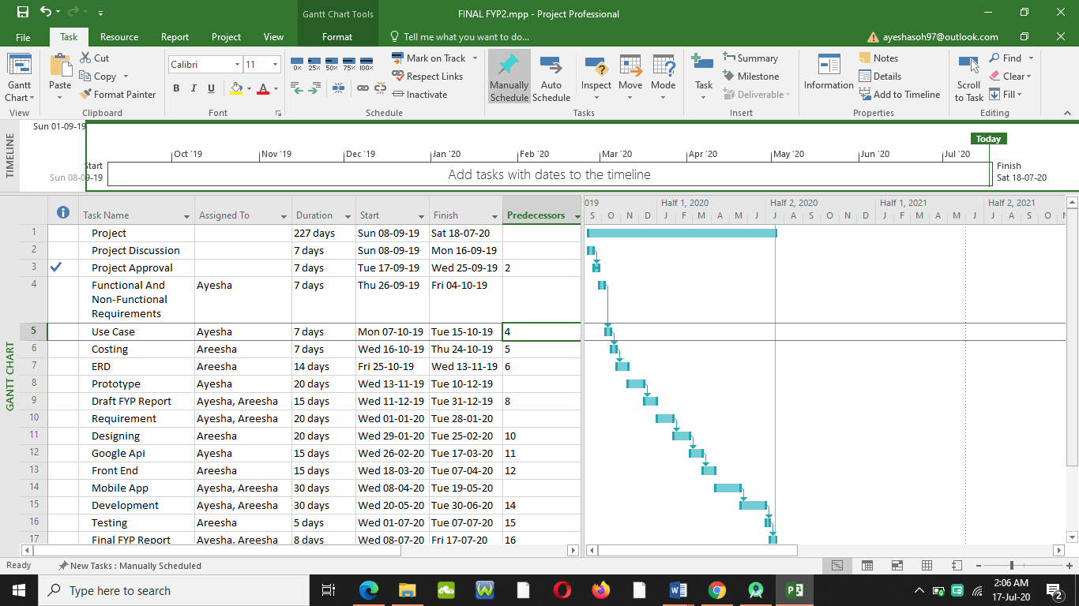

**4.4 USECASE DIAGRAM:**

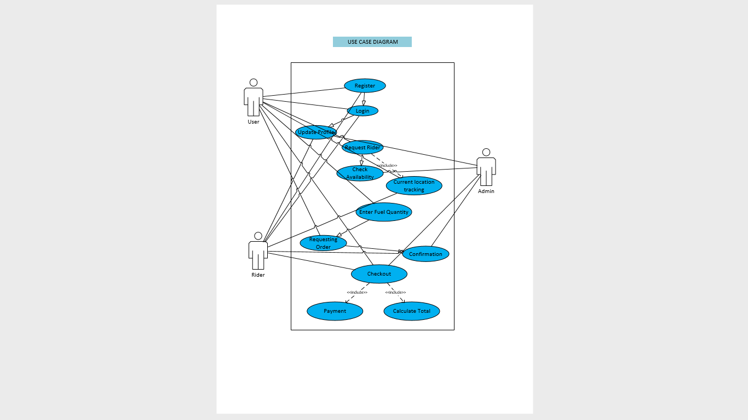

**4.5 CONCEPTUAL ERD:**

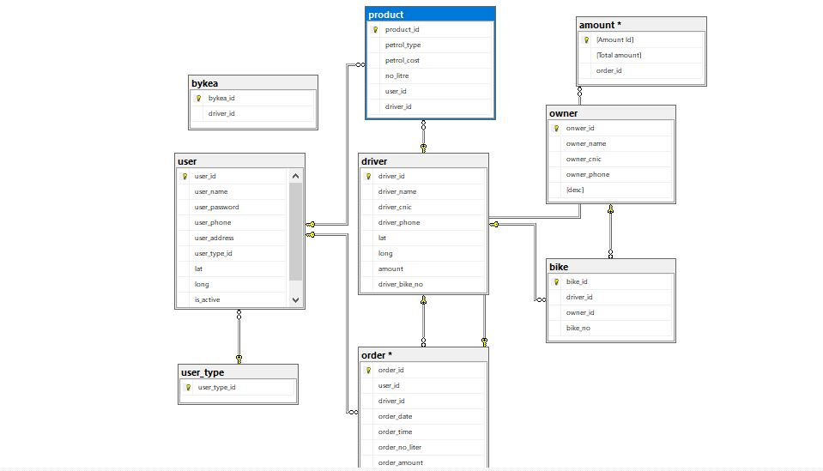

**4.6 UI DIAGRAM:**

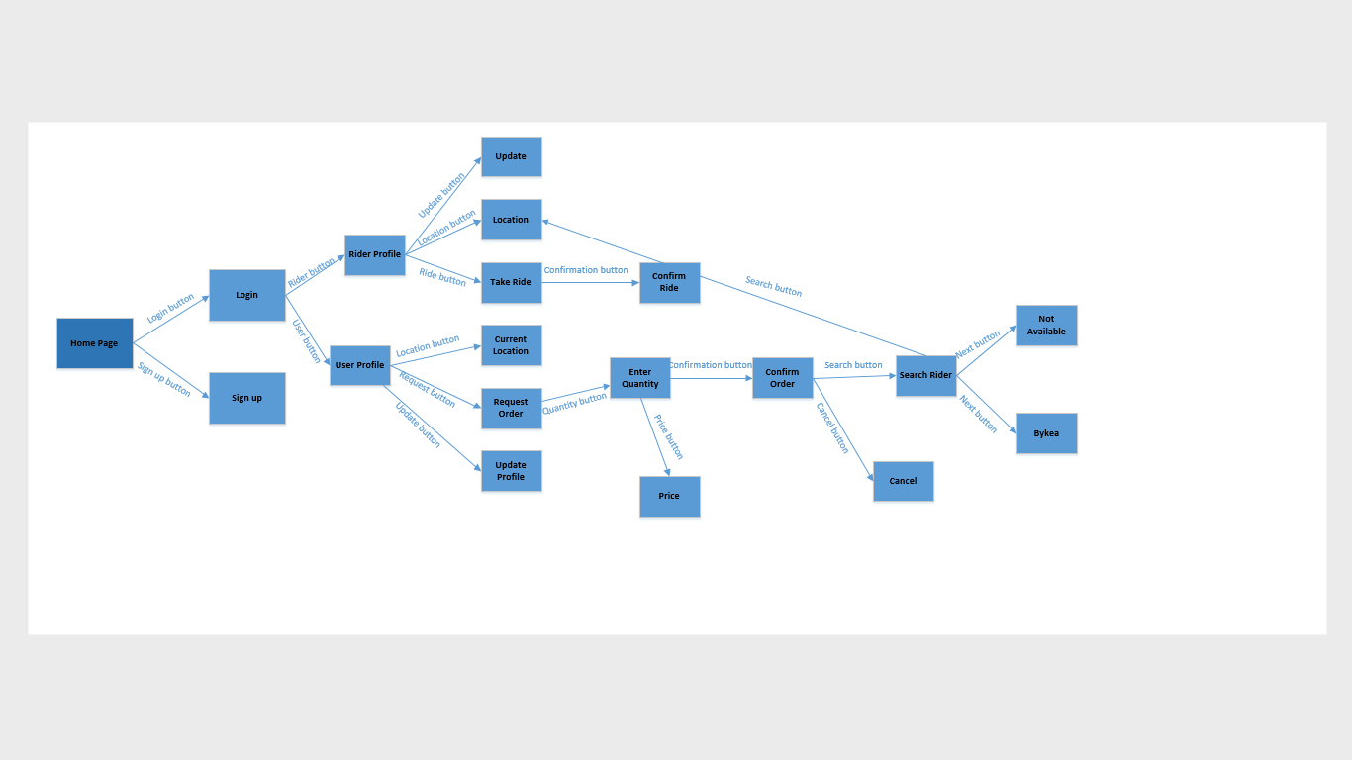

**4.7 PROTOTYPE (BLUEPRINT):**

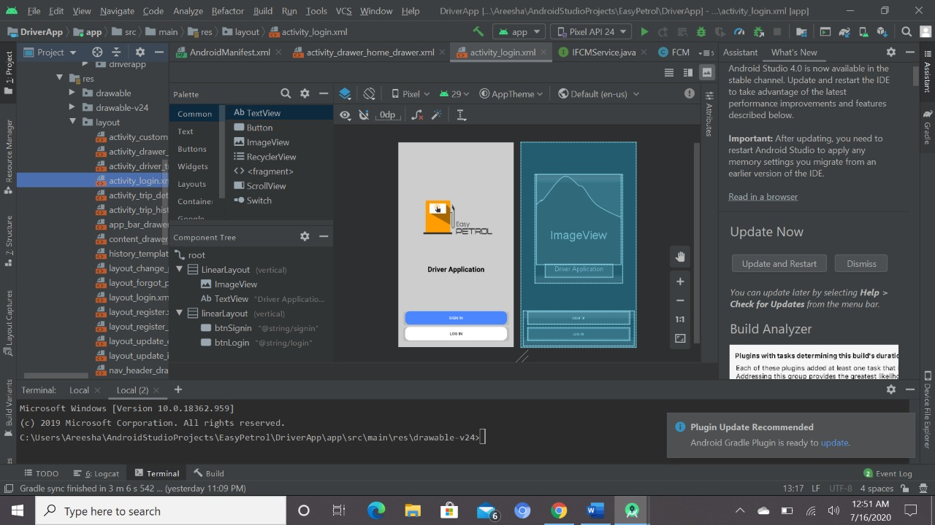

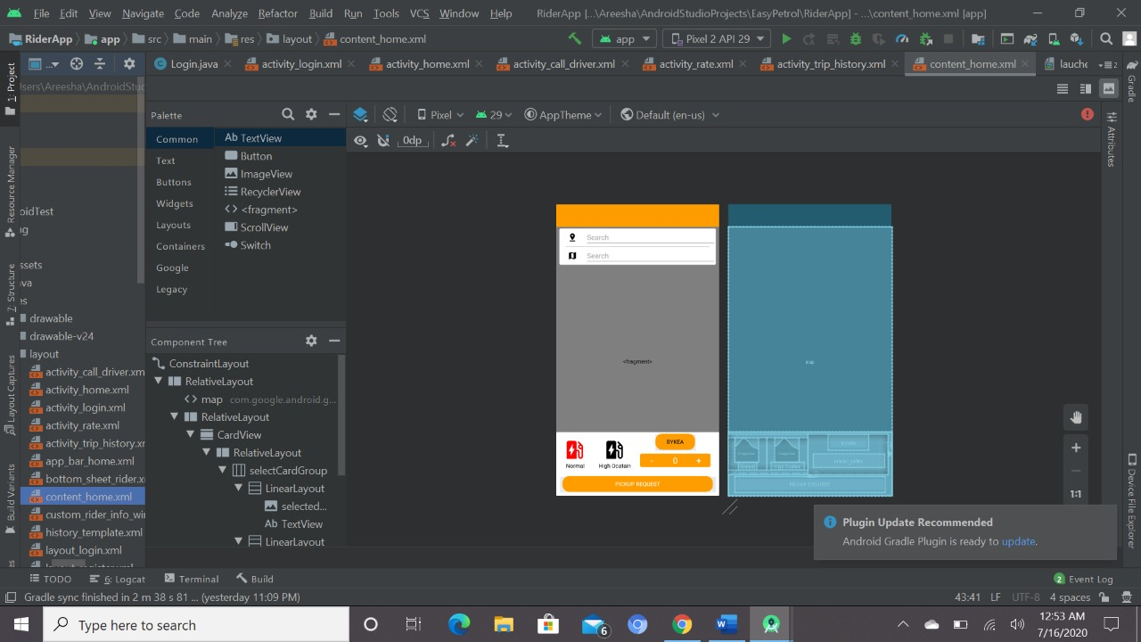

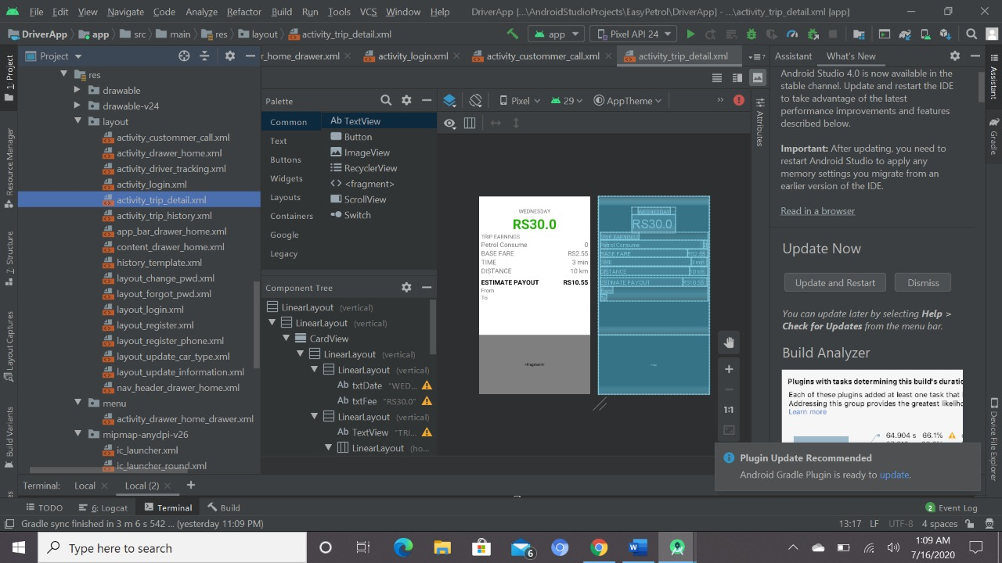

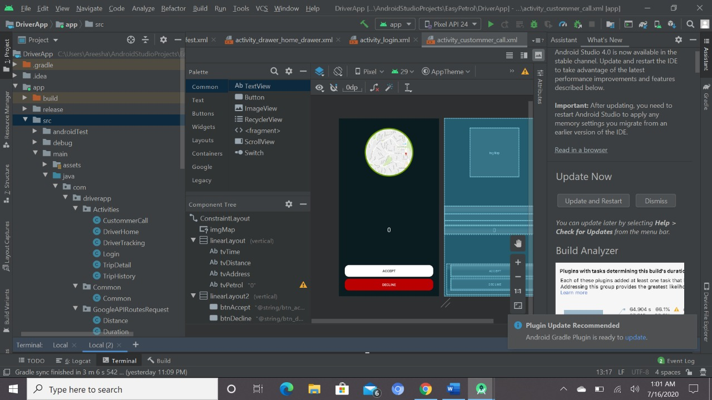

**CHAPTER 05: PROJECT DESIGN & DEVELOPEMENT**

**5.1 DESIGN:**

* FRONT END DESIGN:

**LOGO:**

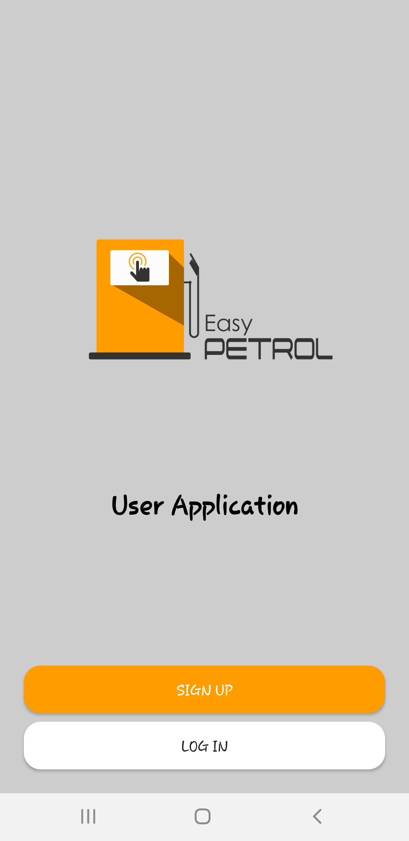

**5.2 ANDROID APPLICATION:**

**LOGIN PAGE:**

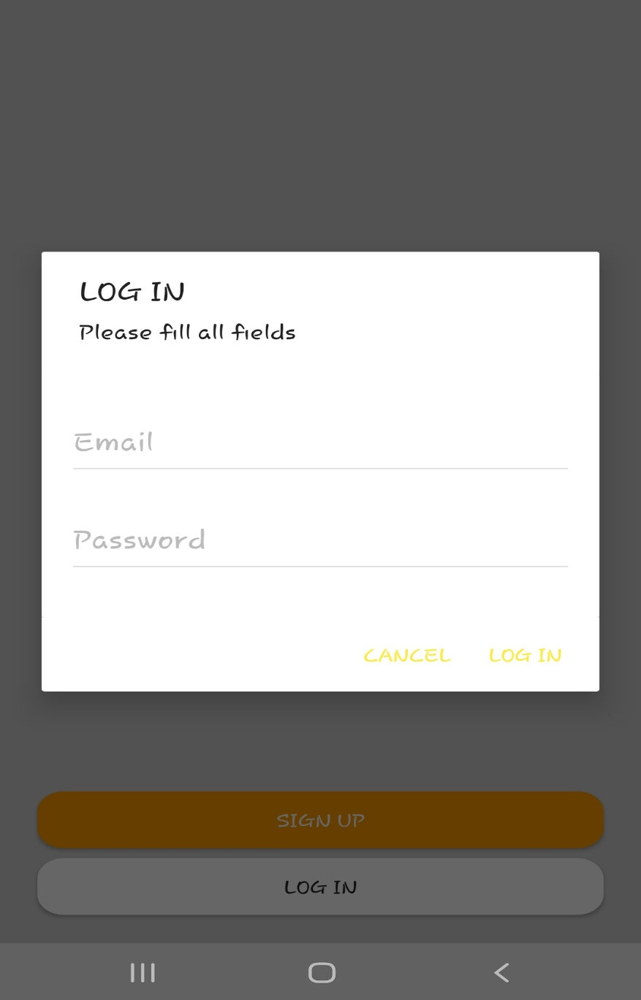

**SIGNUP PAGE:**

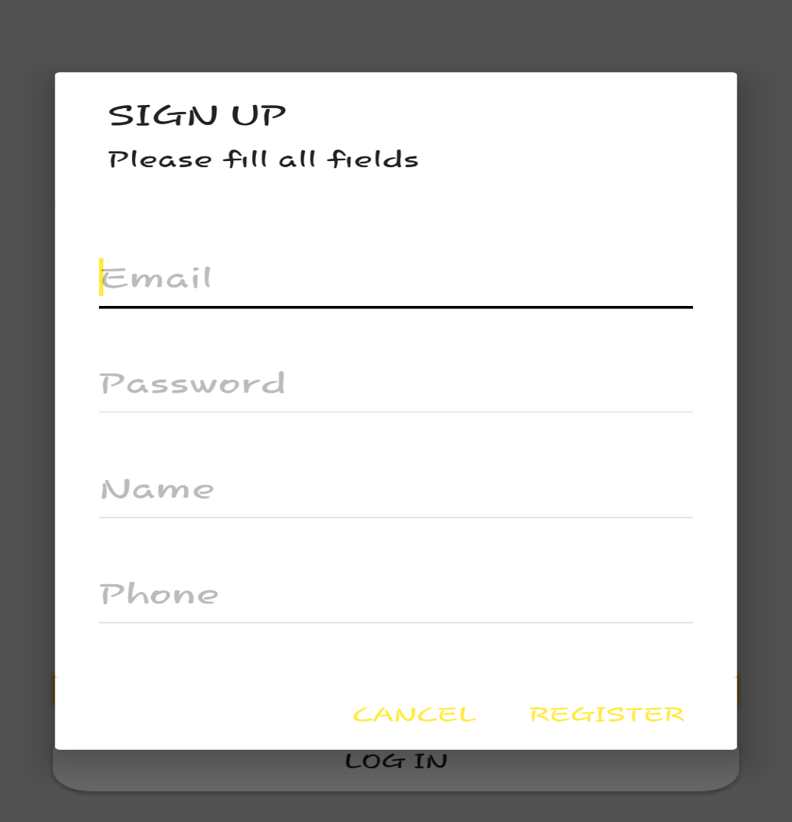

**HOMEPAGE:**

This is the home page of our mobile application where the user can see their current location. Their location must be on, as you can see the petrol type the user will select, you can enter the amount and if incase your rider is not available and you are running out of time you can easily switch to BYKEA as well.

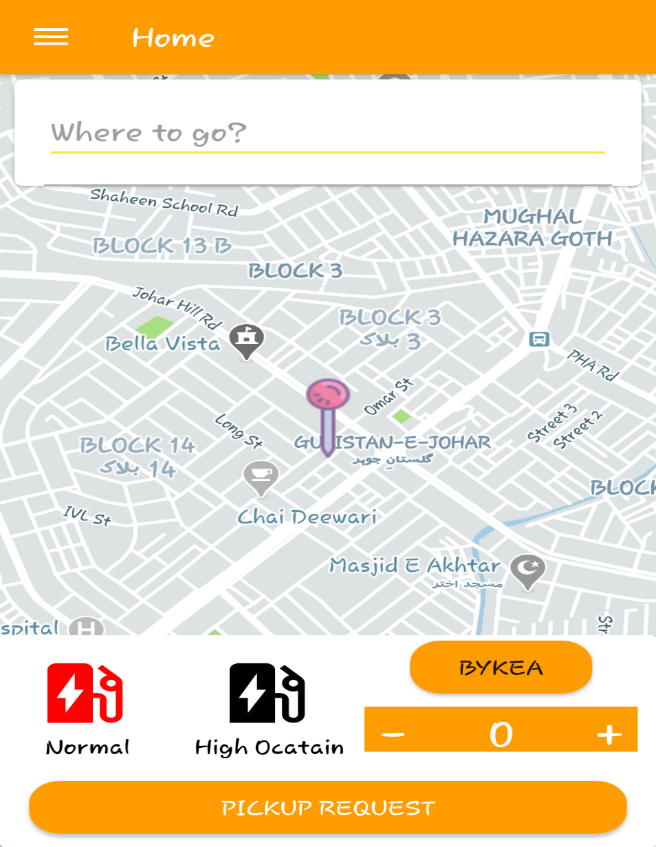

**DETAIL BAR:**

Here you can see all your previous trip/order history and you can even update your data like phone number, name etc.

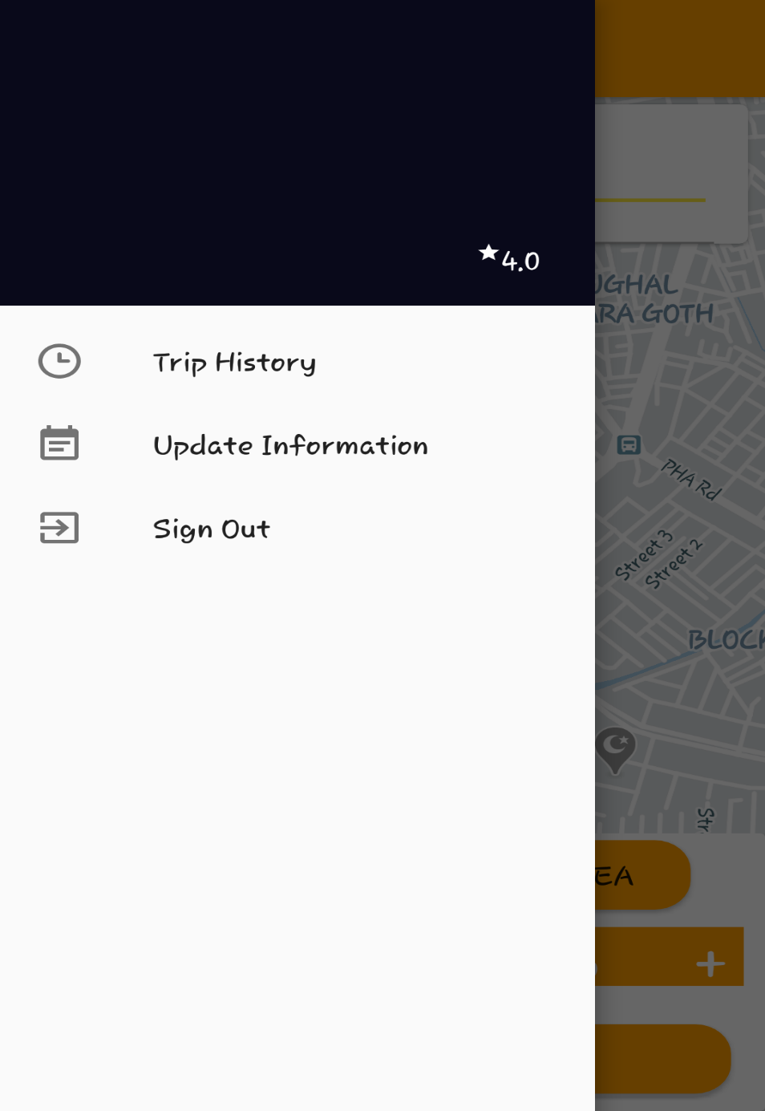

**UPDATE INFORMATION:**

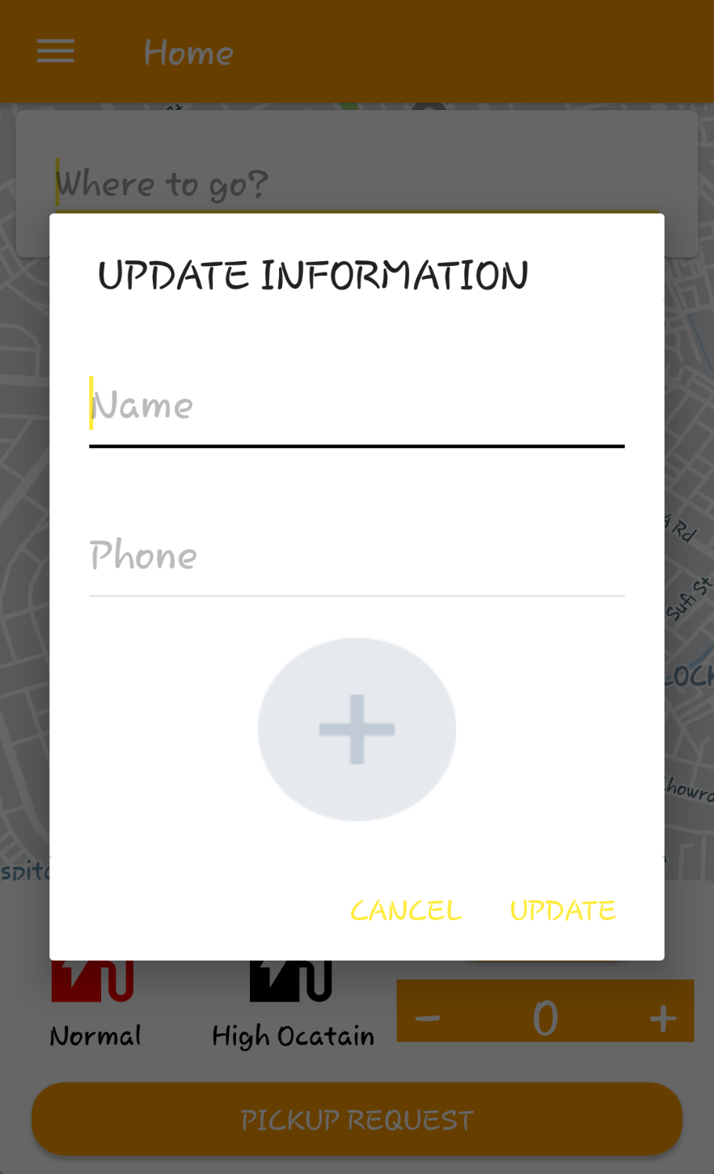

**5.3 ADMIN PANEL:**

This is the admin panel

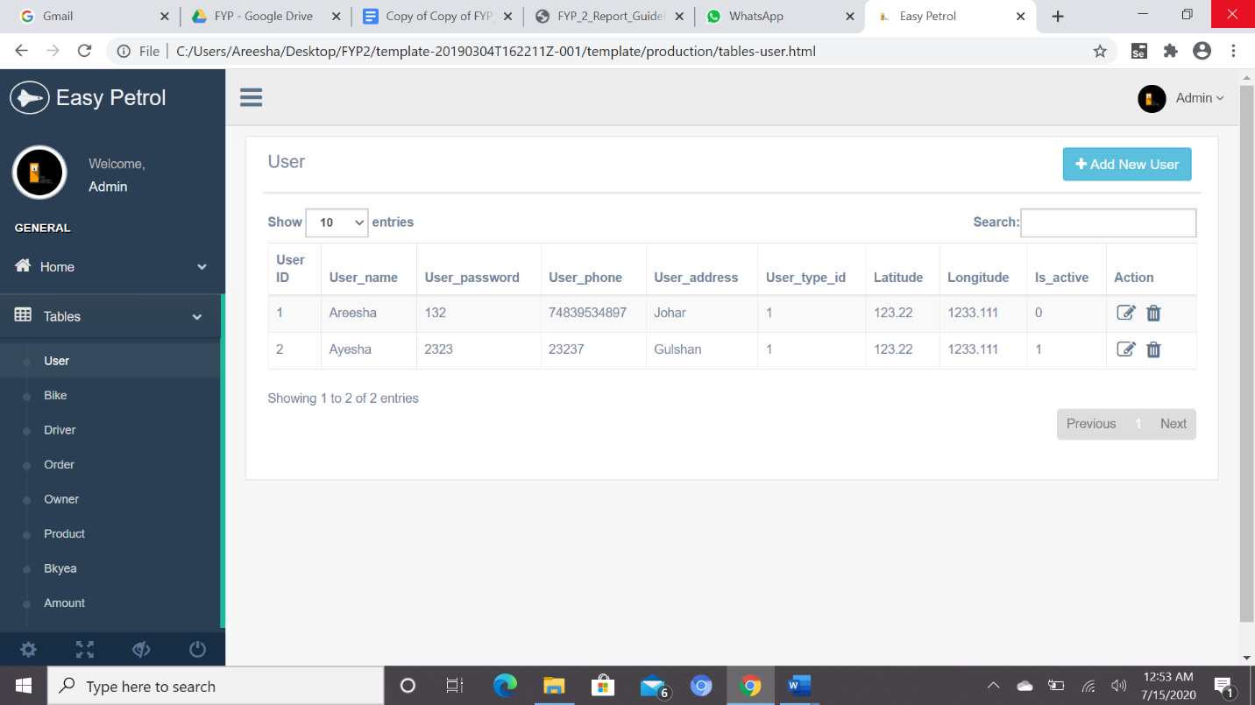

**5.4 FIREBASE:**

This is our database where all the data will be stored as you can see the tables each table detail will be added accordingly like if a new rider is signup to our application information will be added to the database.

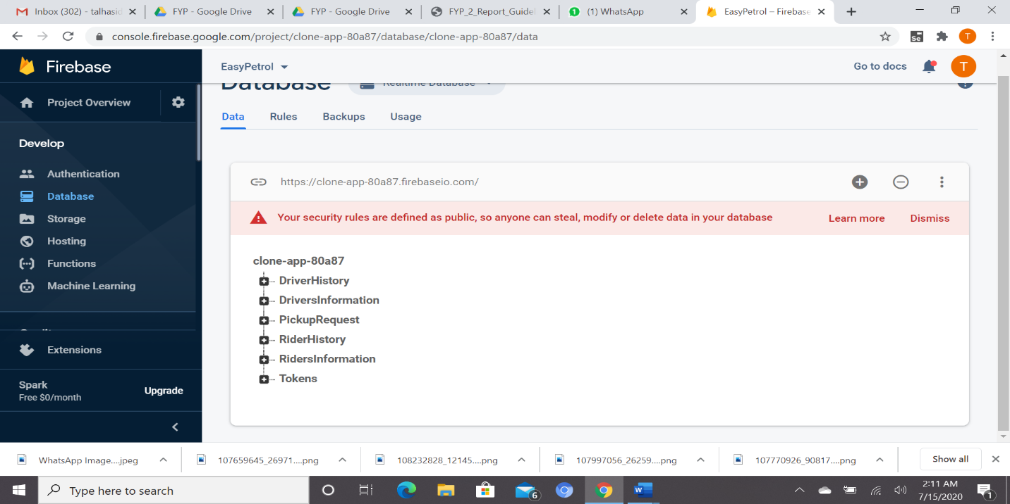

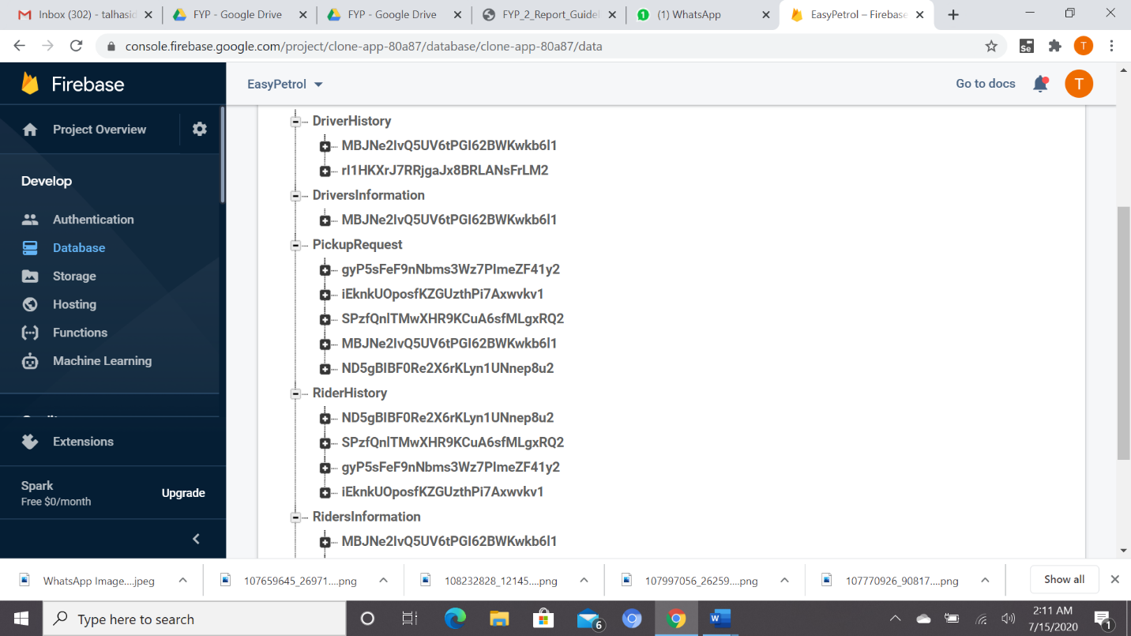

**BACK END DESIGN:**

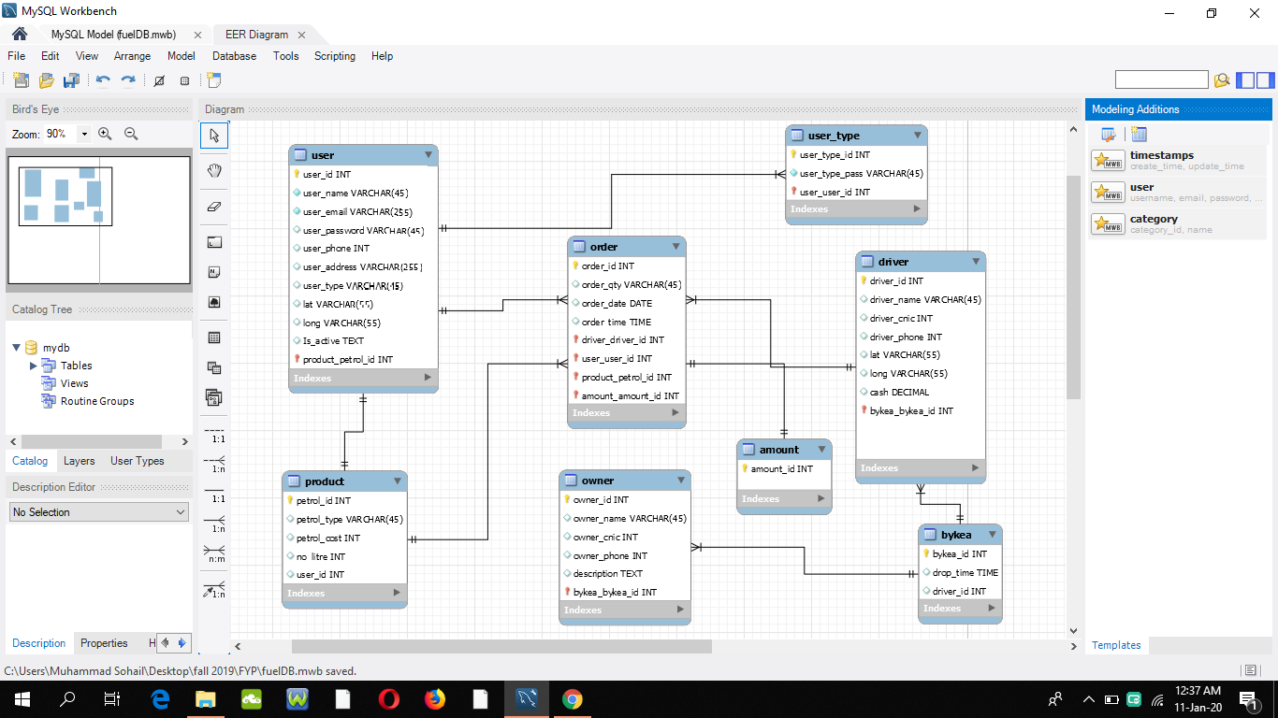

**5.5 DEVELOPMENT:**

When we started making our application the very first thing was looking forward to the login signup pages obviously, they were something studied before as we move forward the very new thing, we worked on was Google service, FCM service and Firebase Database.

* **Google Services**

Android allows us to integrate google maps in our application. You can show any location on the map, or can show different routes on the map etc. You can also customize the map according to your choices.

We have used google services through which we get the Google map API request and Distance, Duration, Lat Long, Routs etc.

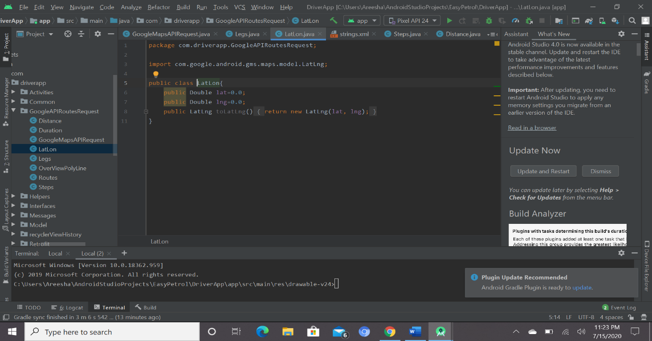

* **FCM service**

When building mobile applications, it is tough to think of a use case where you **do not** need to notify users with [alerts or push notifications](https://www.pubnub.com/use-case/alerts-and-push-notifications/). For example, let us consider the following scenario:

If the rider have accepted the users request for the fuel how the user would know that the rider has accepted the request, or if the user have cancelled the request. How we will notify this to the rider these were some points we used to think about then we came to know that, In Android, the mechanism native applications use for push notifications is [Firebase Cloud Messaging](https://firebase.google.com/docs/cloud-messaging/) (FCM) notifications. **Notification messages**, sometimes thought of as “display messages.” These are handled by the FCM SDK automatically.

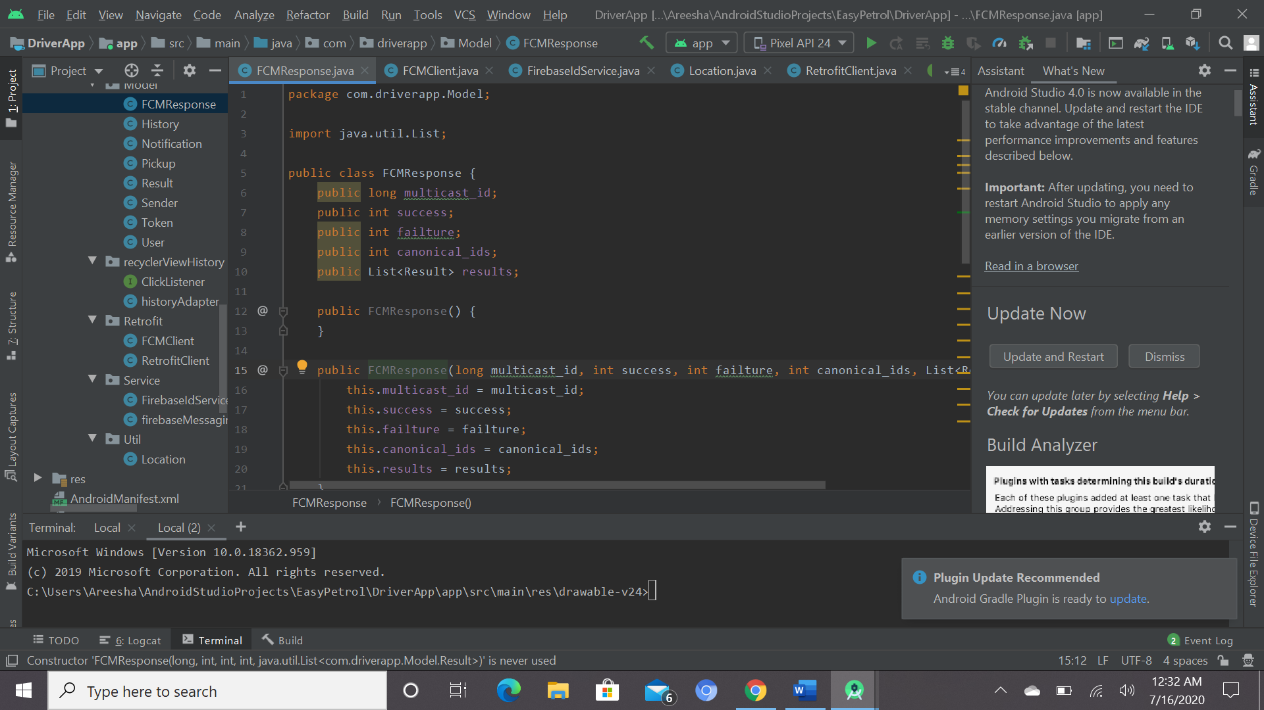

* **FIREBASE DATABASE**

Databases are an important part of any of our project. We store, retrieve, delete and update our data in the database taken from the application or from the software that we have made. Things become harder when you want to update and save all the data at real-time i.e. whenever you update the data, that updated data should be reflected back in your application at that very instant. So, for real time purpose we use Firebase Realtime Database

The data stored in the Firebase Realtime Database will be reflected at real-time i.e. if there is a change in the values in the database then that change will be reflected back to all the users at that instant only and no delay will be there.

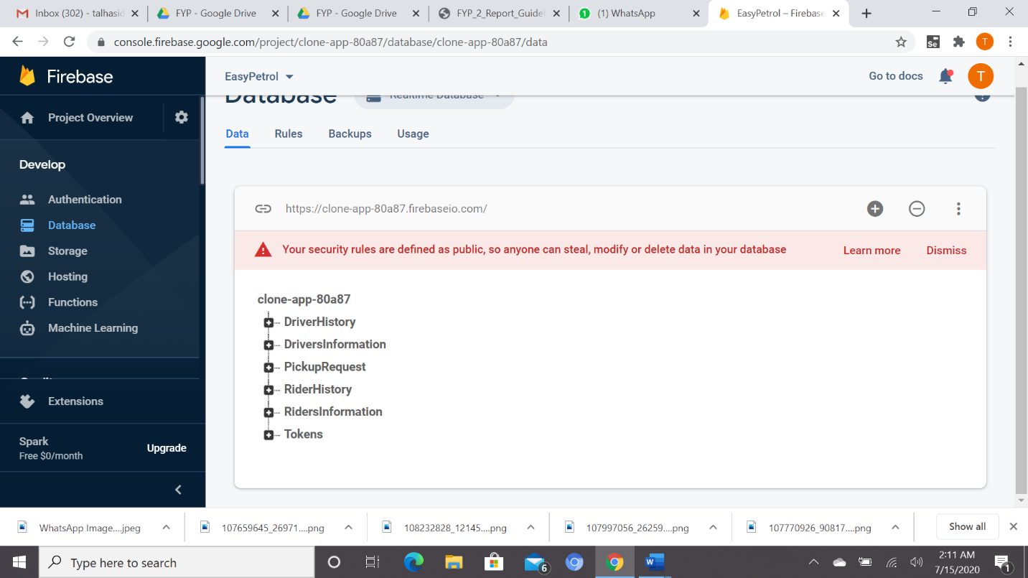

**5.6 PROJECT STRUCTURE & FOLDERS:**

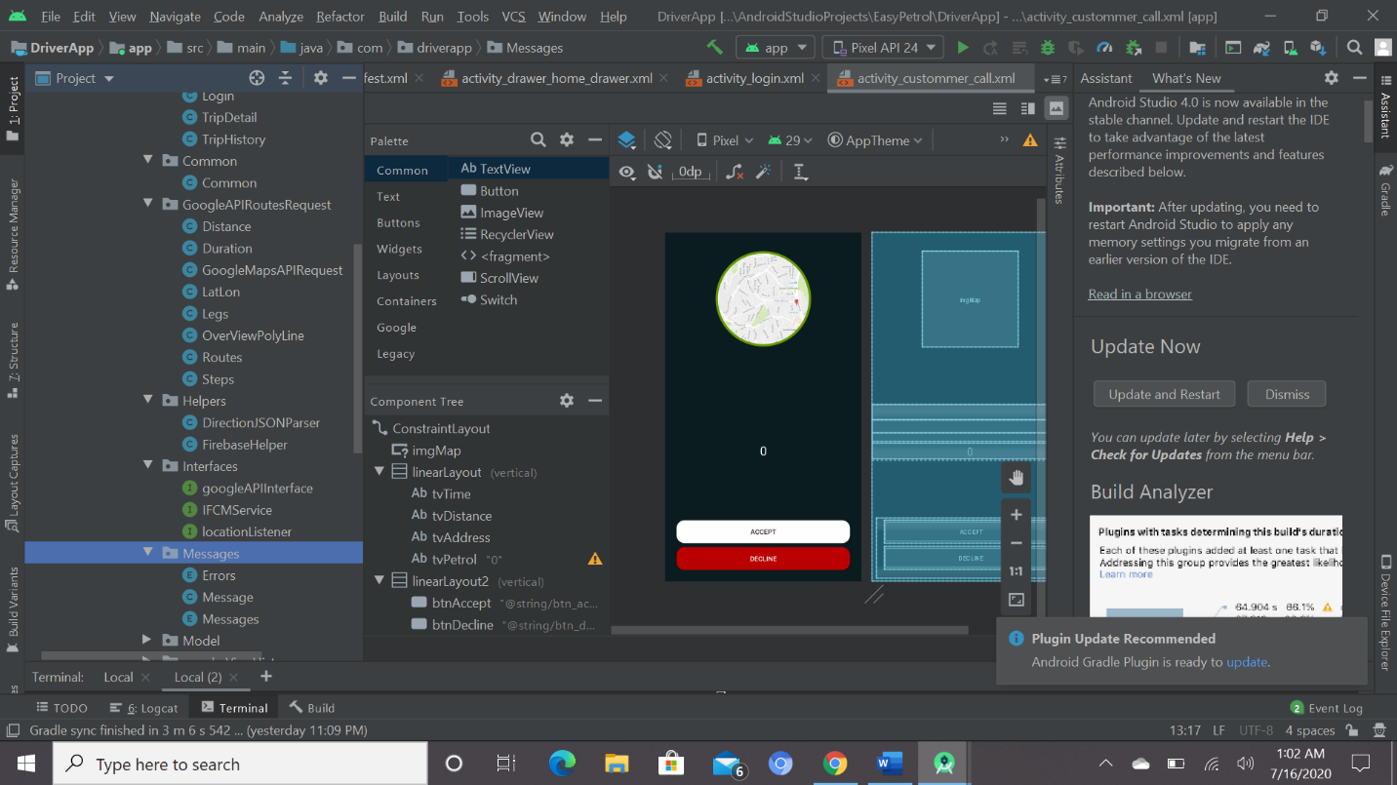 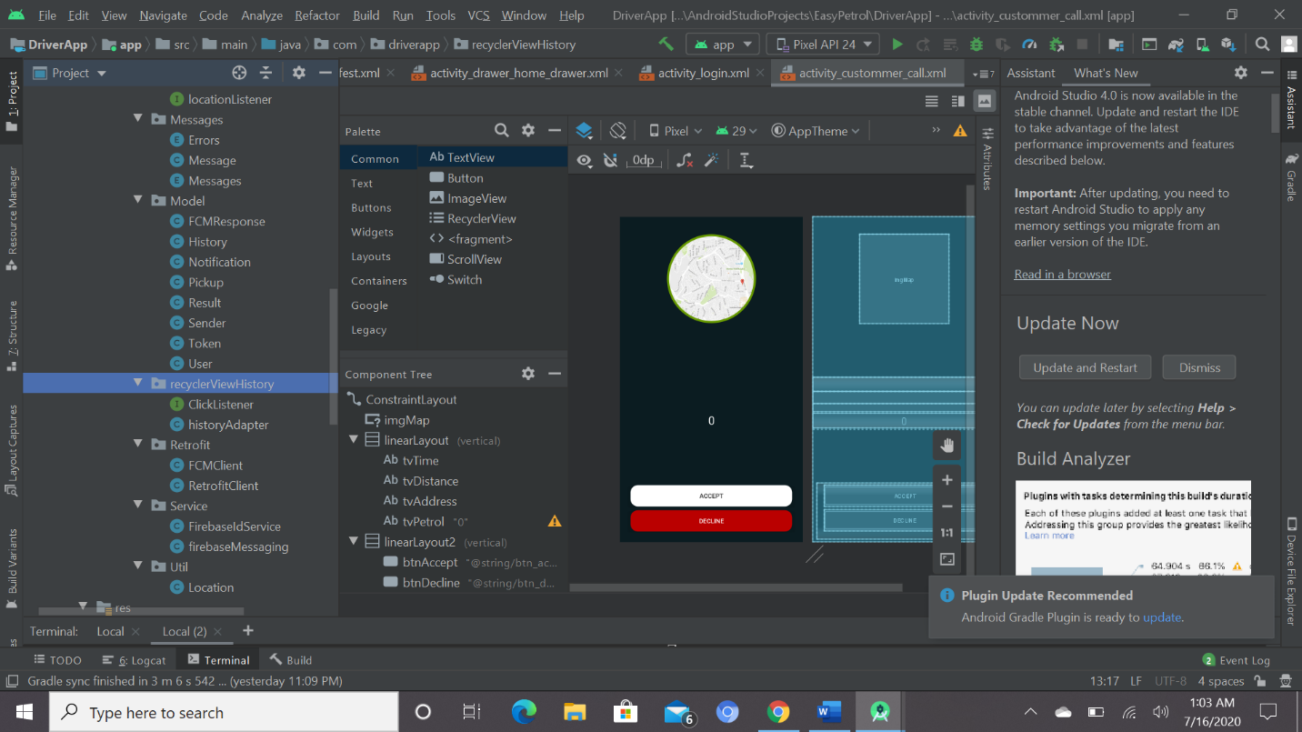 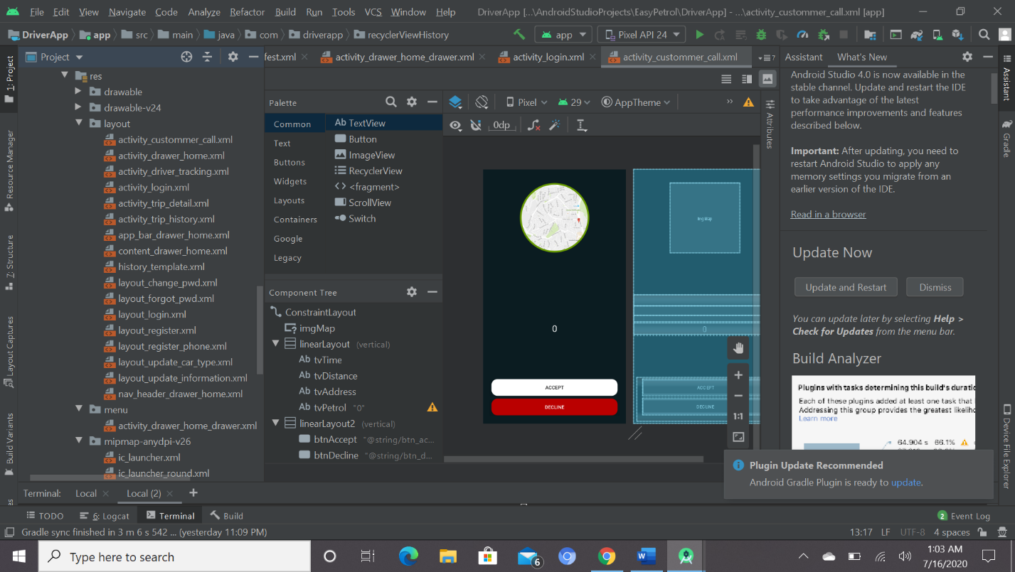

**LAYOUT:**

The most convenient and maintainable way to design application user interfaces is by creating XML layout resources. This method greatly simplifies the UI design process, moving much of the static creation and layout of user interface controls and definition of control attributes, to the XML, instead of littering the code.

As per our Coordinators suggestion first we created a prototype on paper that how we want our applications layout and what colors we want so after this we started working.

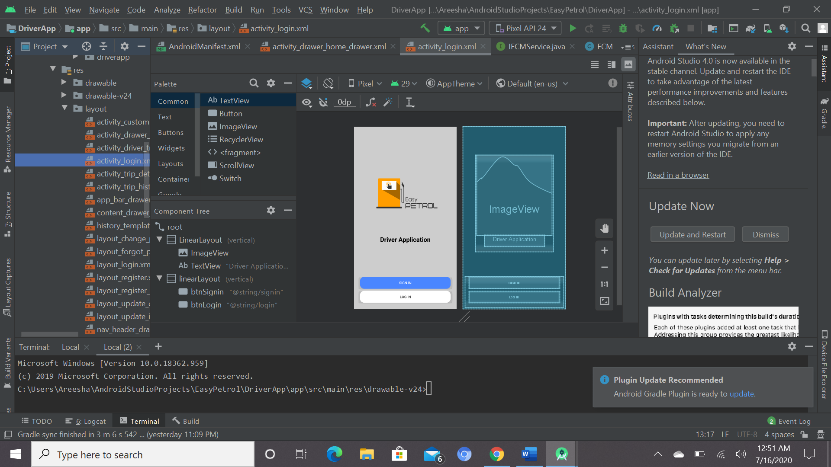

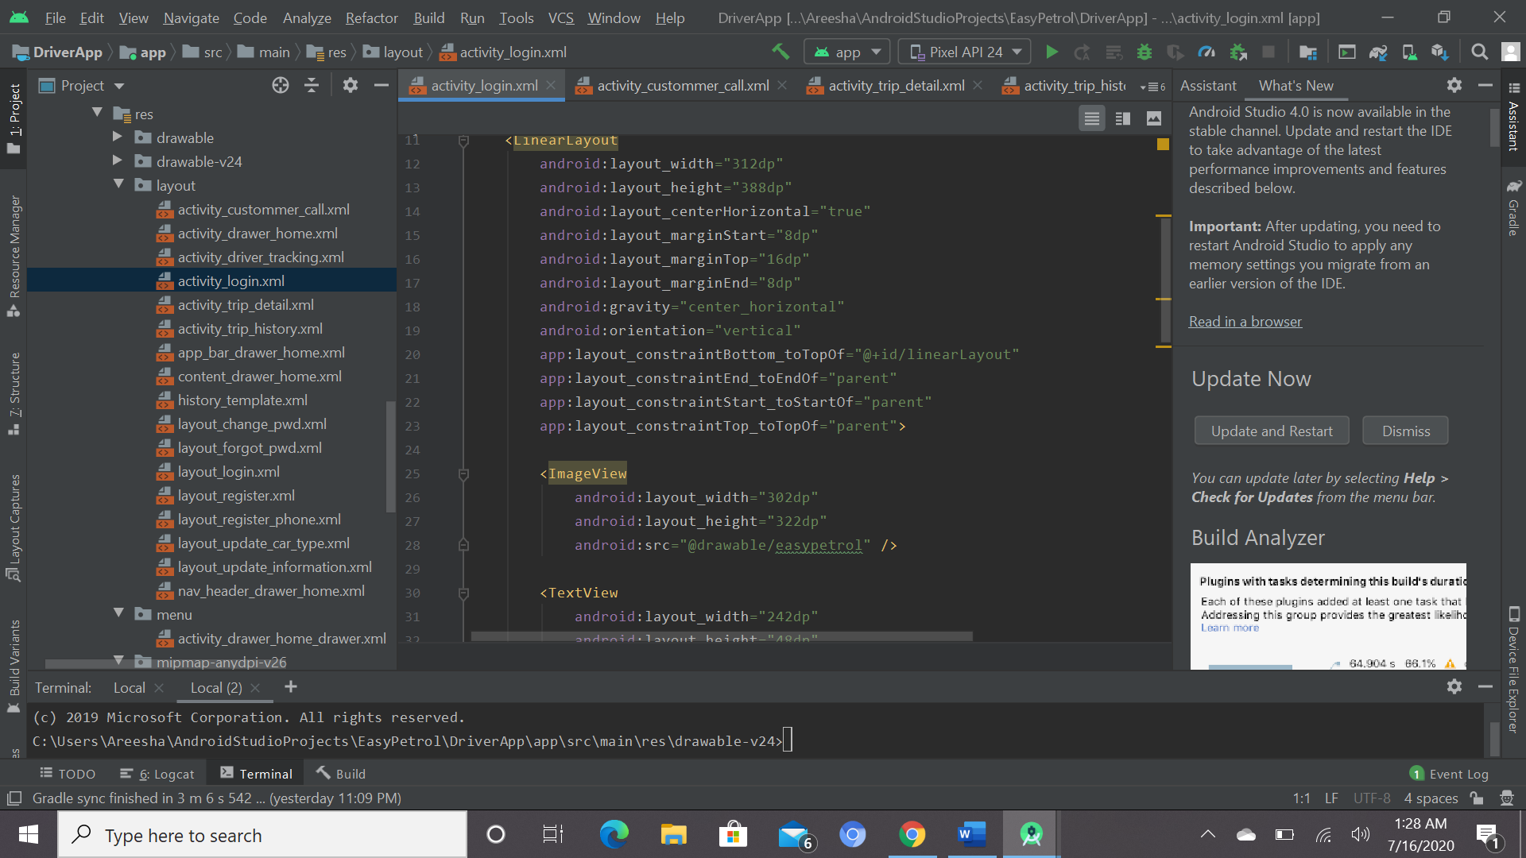

In design layout the XML file deals with buttons , sizes of buttons , colors everything in detail like we have selected Yellow color for buttons and our logo so that’s why our background color is light. Each and every page is degined in similar way.

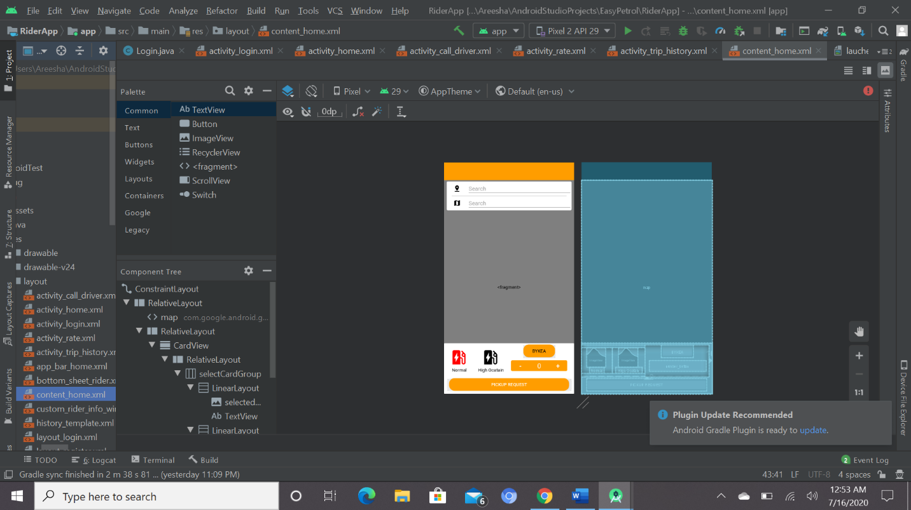

This is the layout of the user home page where the user can select the petrol type and by turning on the location the google map will appear user can select the quantity as well all this designing was done by making a layout first even the size of map was chosen according to the prototype we made before.

**5.7 LIBRARIES USED IN OUR PROJECT:**

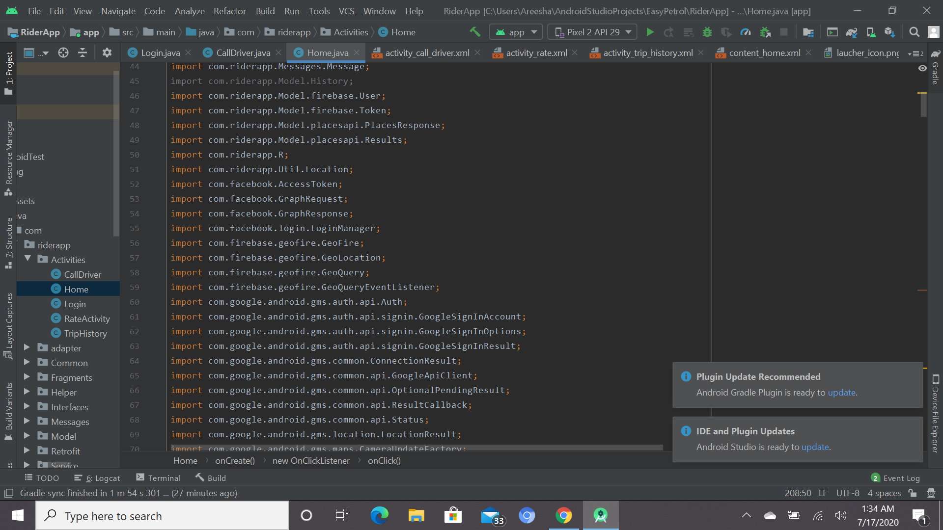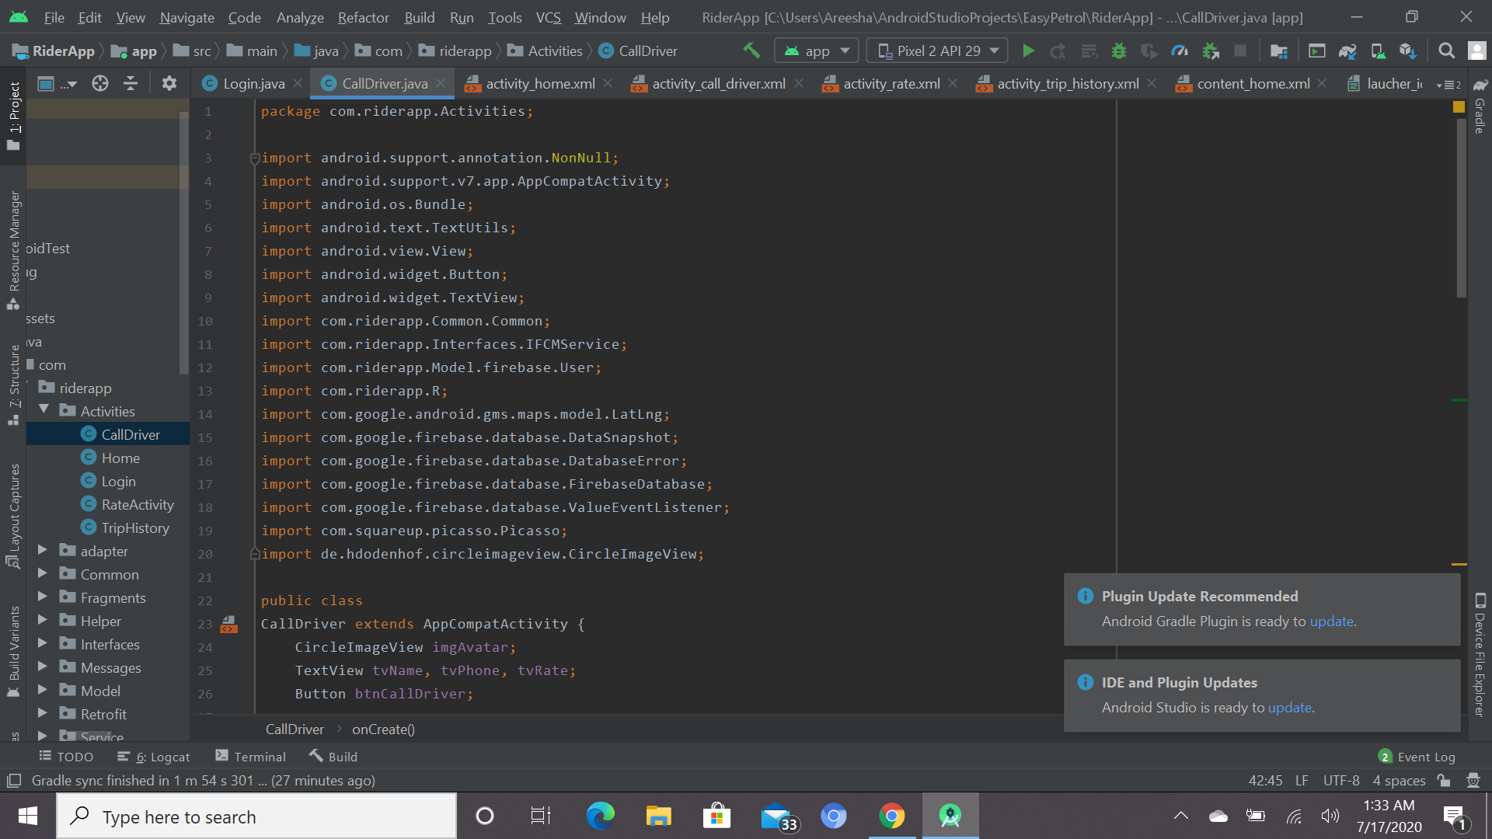

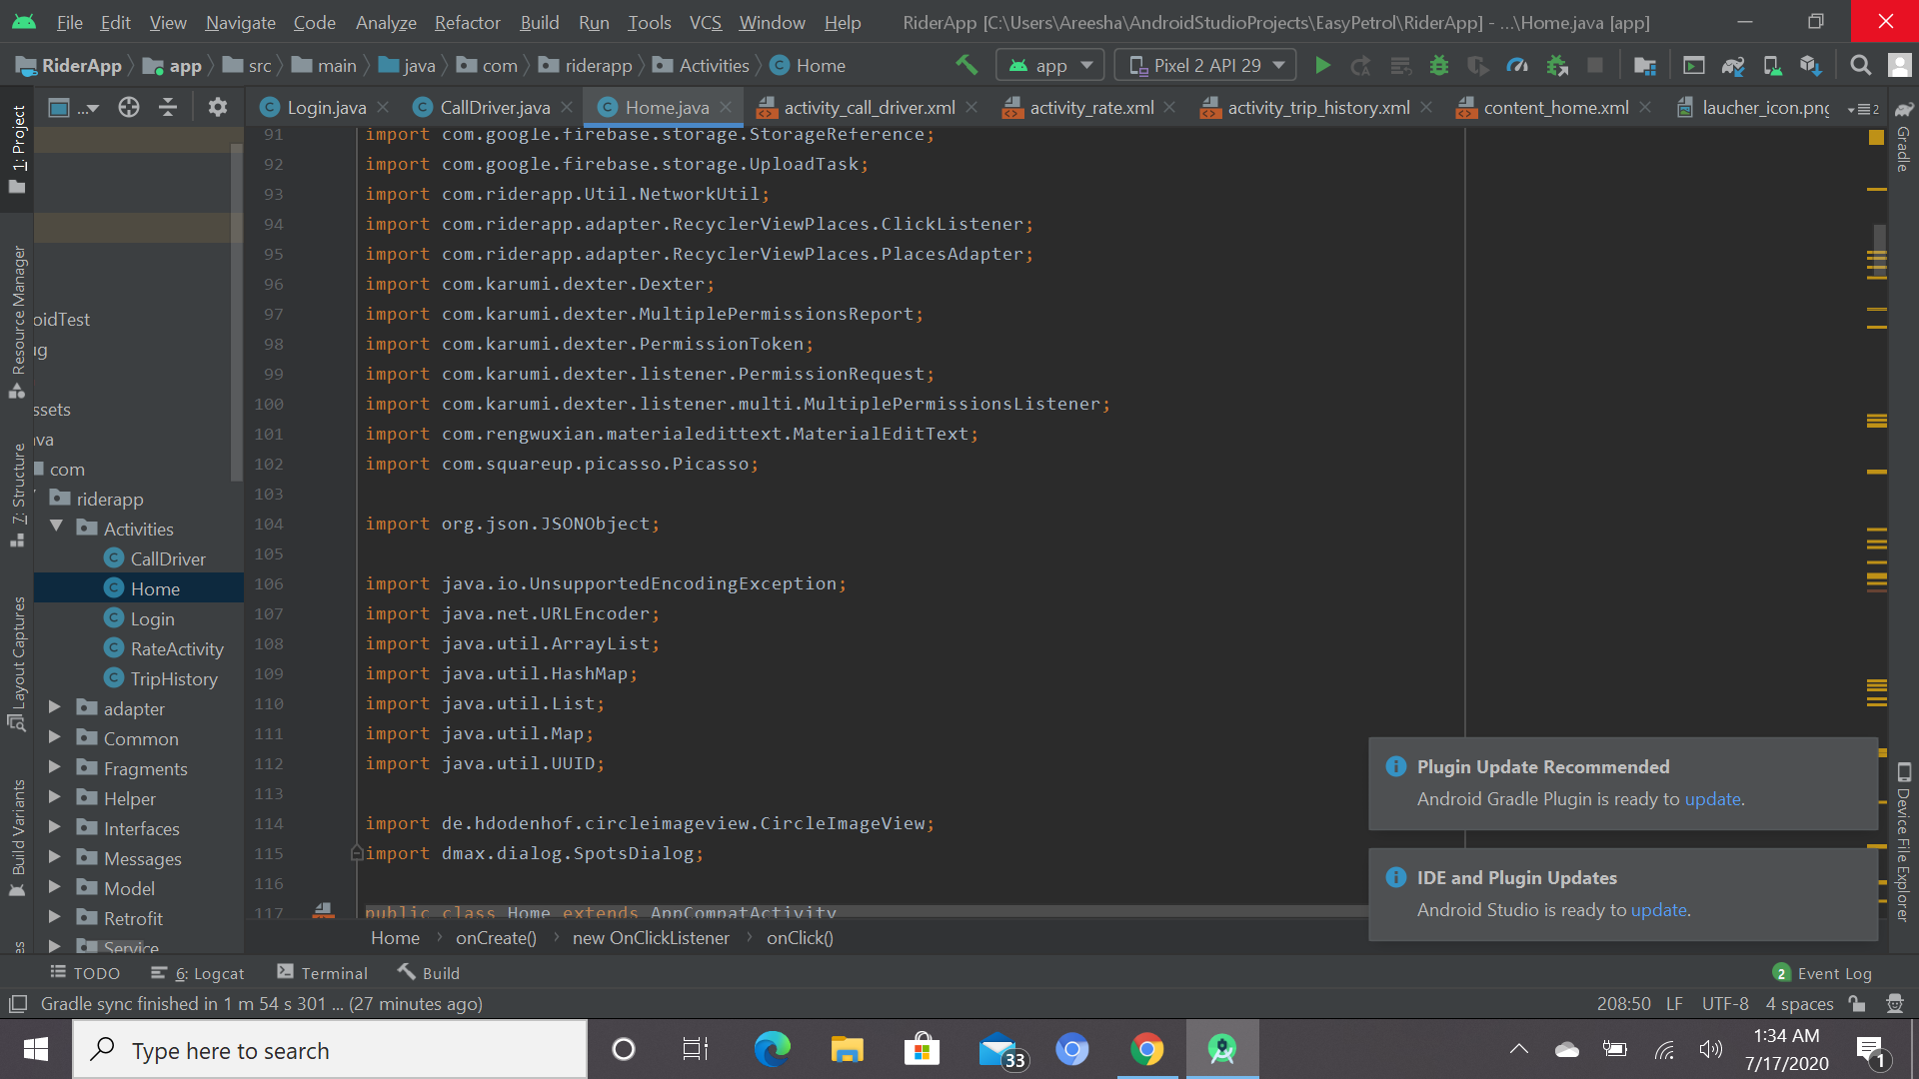 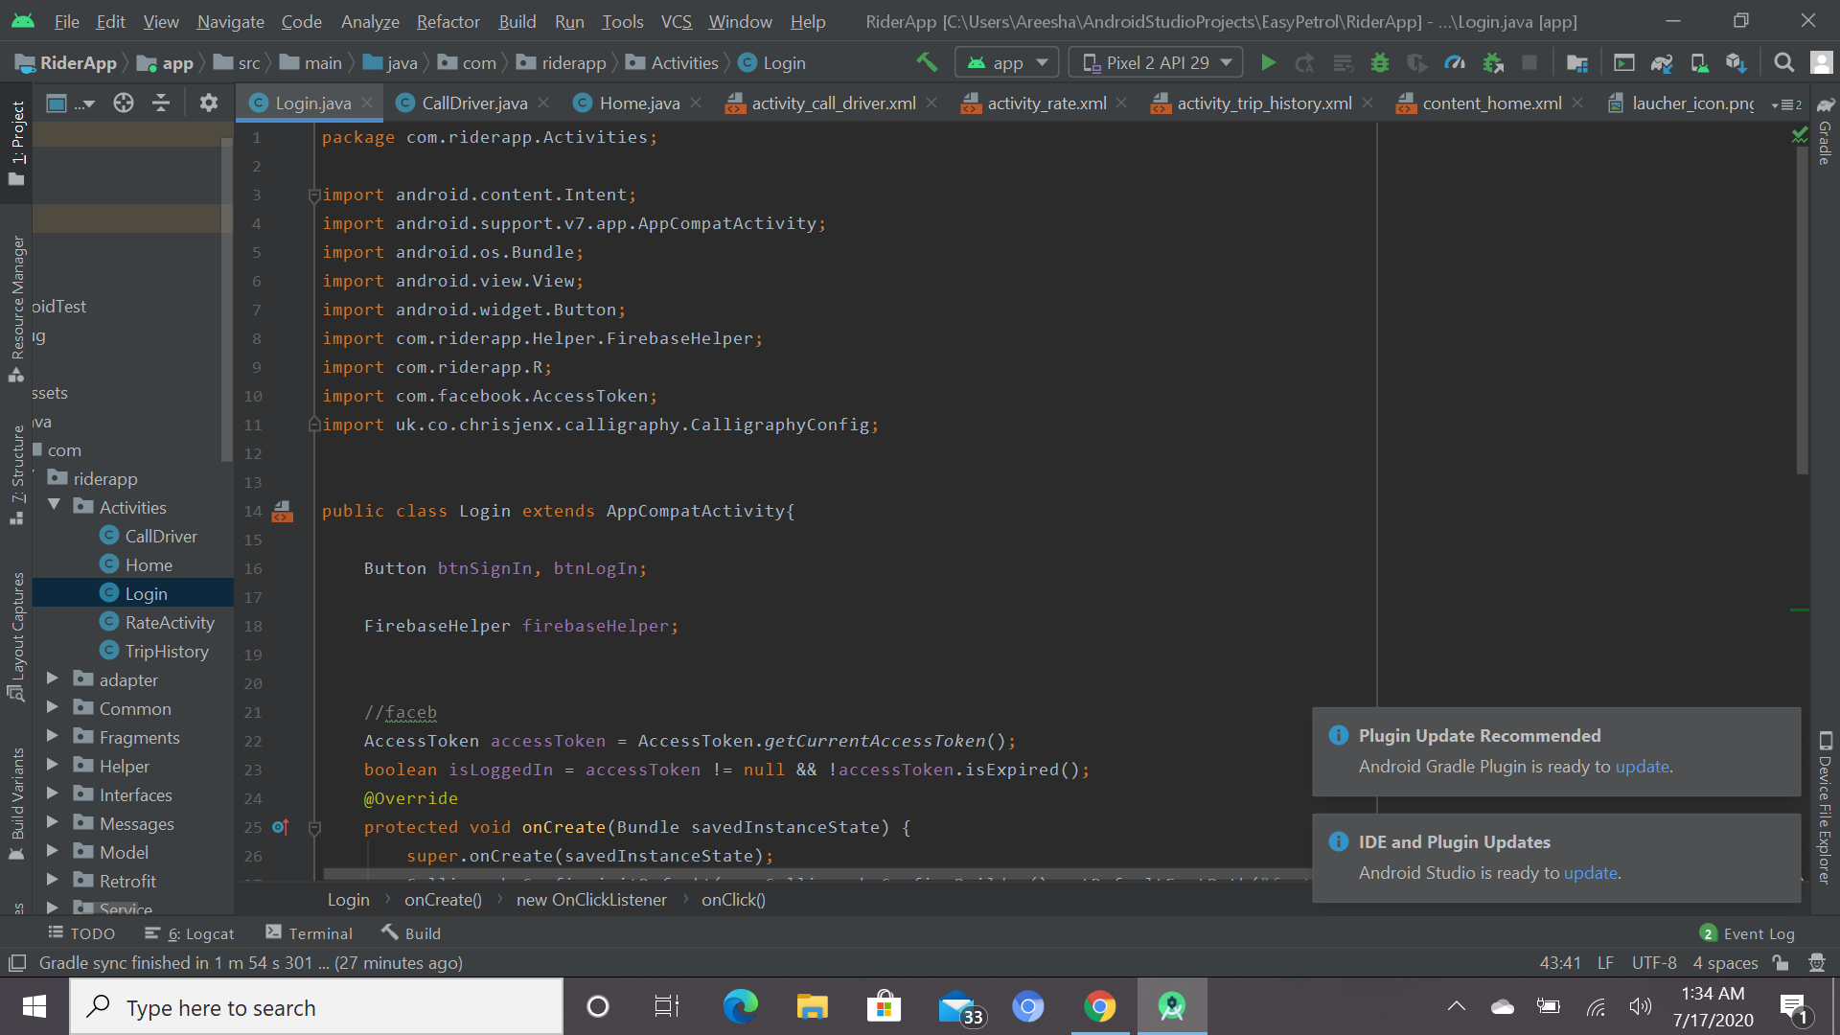

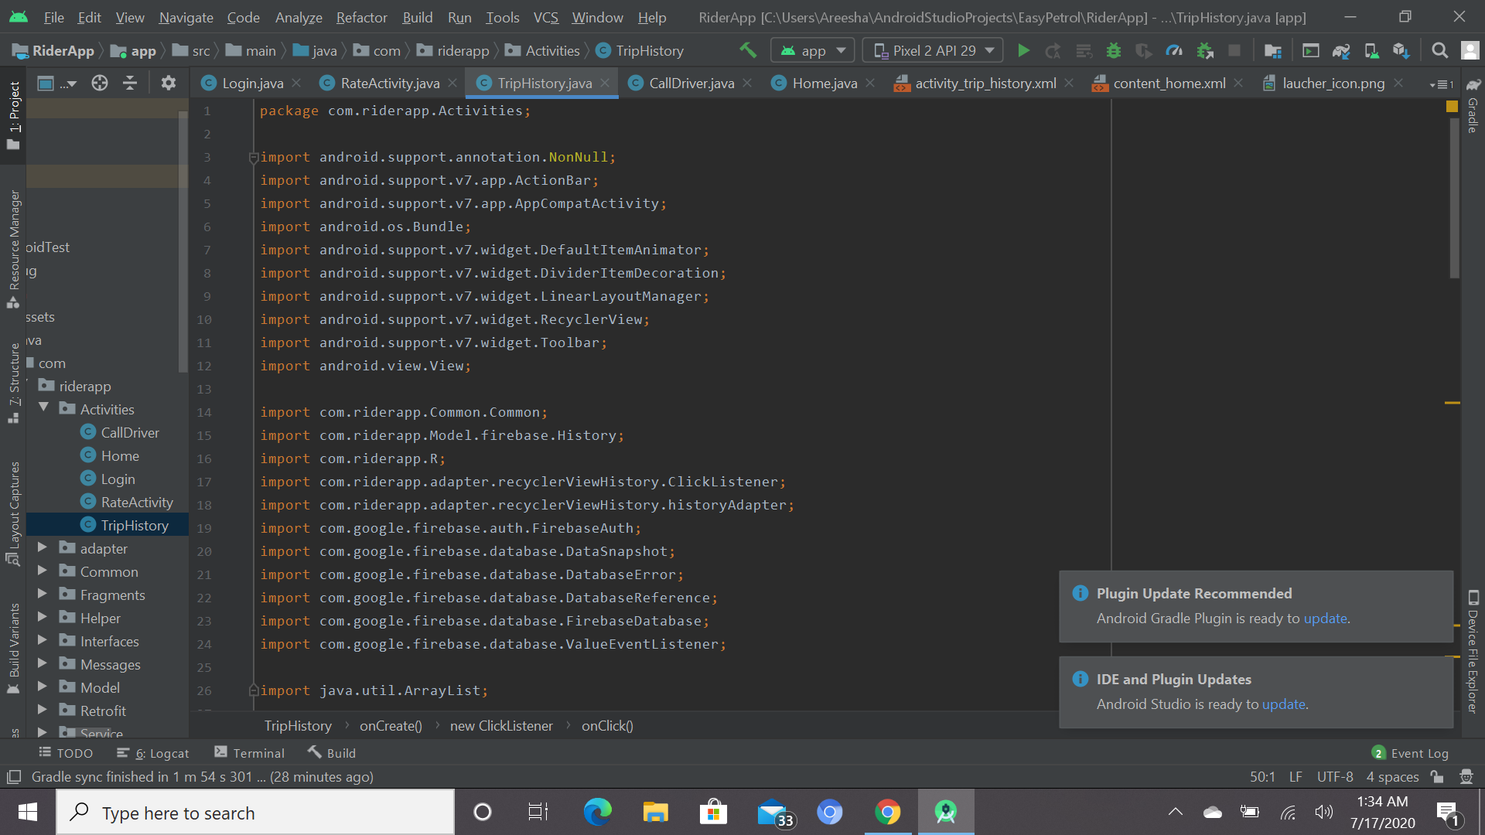 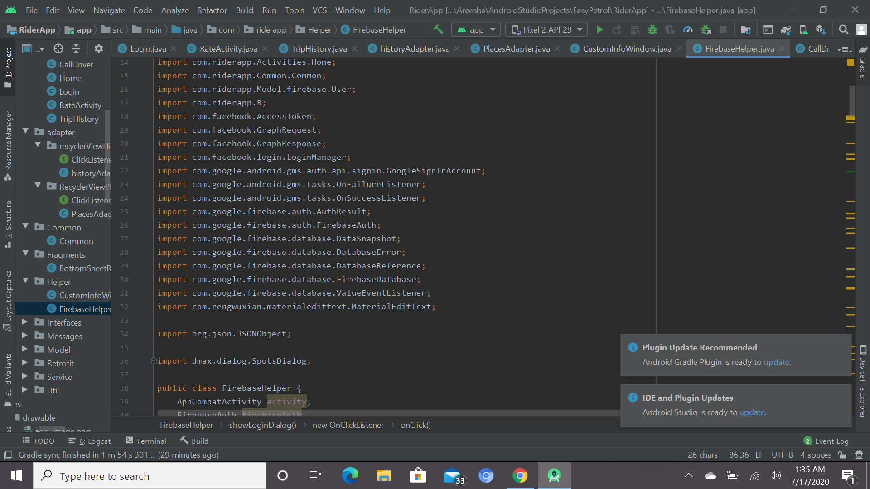

**We have used latest version of Android Studio**

**Firebase database**

**5.8 DATABASE QUERIES:**

* **UPDATE**

UPDATE Rider Information

SET name = ‘Areesha’, email = ‘Areesha78@gmail.com’

WHERE Column Name = SPzFQnTM

* **DELETE**

DELETE FROM Rider History WHERE name = ‘Ayesha’

**5.9 SCREENSHOT OF RUNNING PROJECT:**

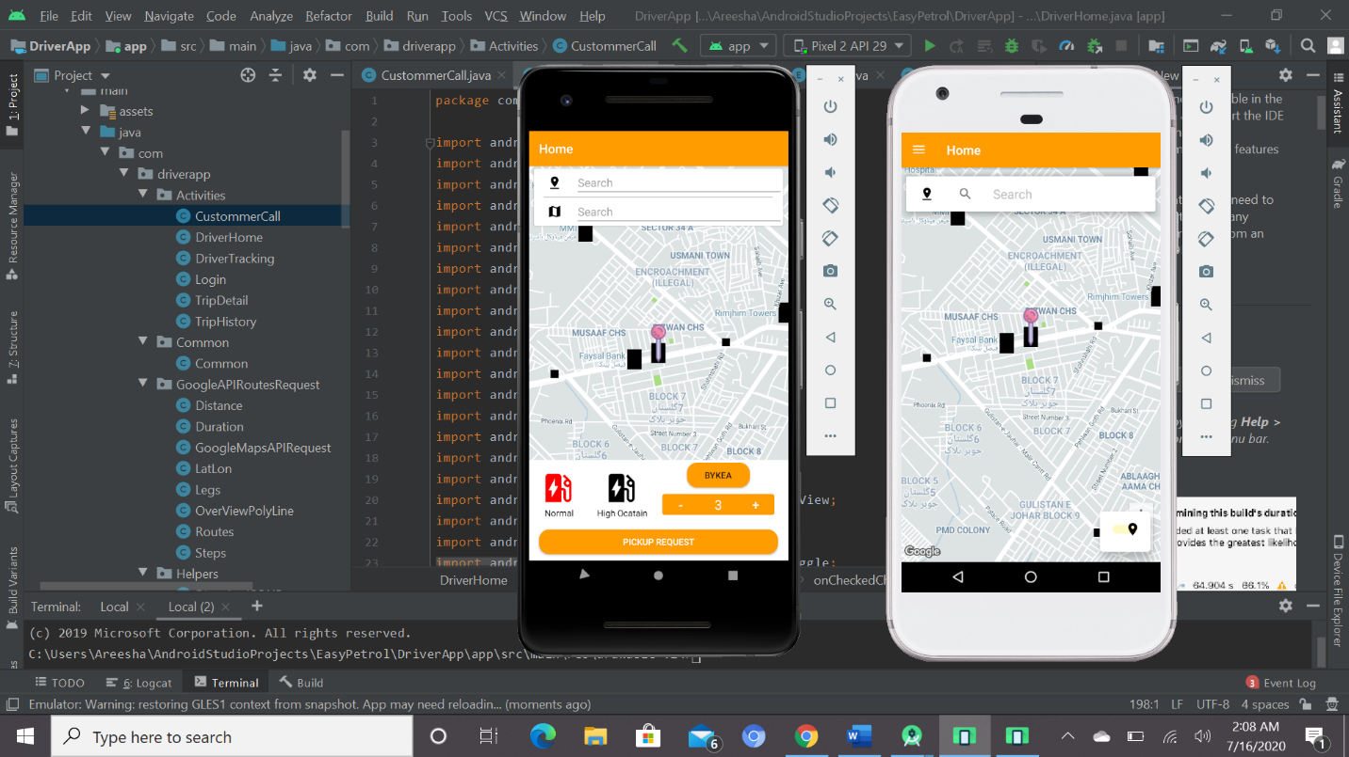

**CHAPTER 06: TESTING**

**6.1 FRONTEND TESTING:**

|  |  |
| --- | --- |
| **TEST CASE ID** | EP-01 |
| **TEST CASE** | Signup |
| **PAGE** | Signup |
| **PRE-REQUISITES** | User should have application downloaded |
| **TEST PROCEDURE** | Enter the details to sign up. |
| **EXPECTED RESULT** | The user will successfully be signed up and now can login to the application |
| **ACTION RESULT** | PASS |
| **TEST CASE: Signup** | |

|  |  |
| --- | --- |
| **TEST CASE ID** | EP-02 |
| **TEST CASE** | Login |
| **PAGE** | Login |
| **PRE-REQUISITES** | Must be logged in |
| **TEST PROCEDURE** | Enter valid ID and Password |
| **EXPECTED RESULT** | Login successful and redirect to the homepage otherwise invalid username and password message |
| **ACTION RESULT** | PASS |
| **TEST CASE: LOGIN** | |

|  |  |
| --- | --- |
| **TEST CASE ID** | EP-03 |
| **TEST CASE** | User Homepage |
| **PAGE** | Dashboard |
| **PRE-REQUISITES** | User must be logged in |
| **TEST PROCEDURE** | After login the first page generated is the user homepage |
| **EXPECTED RESULT** | View of homepage, running project |
| **ACTION RESULT** | PASS |
| **TEST CASE: User Homepage** | |

|  |  |
| --- | --- |
| **TEST CASE ID** | EP-04 |
| **TEST CASE** | User Location |
| **PAGE** | Location |
| **PRE-REQUISITES** | To see current location |
| **TEST PROCEDURE** | Turn on the location first |
| **EXPECTED RESULT** | User must be able to see the current location but first turn on the location |
| **ACTION RESULT** | PASS |
| **TEST CASE: Location** | |

|  |  |
| --- | --- |
| **TEST CASE ID** | EP-05 |
| **TEST CASE** | User profile page |
| **PAGE** | Edit profile |
| **PRE-REQUISITES** | User should click on the left side bar |
| **TEST PROCEDURE** | User can update their information and click to save changes all the changes will be saved to the database. |
| **EXPECTED RESULT** | All the information is updated to the DB successfully |
| **ACTION RESULT** | PASS |
| **TEST CASE: User Profile** | |

|  |  |
| --- | --- |
| **TEST CASE ID** | EP-06 |
| **TEST CASE** | User Trip History |
| **PAGE** | View Previous Trip history |
| **PRE-REQUISITES** | User should click on the left side bar |
| **TEST PROCEDURE** | User can see their previous trip history to check their record |
| **EXPECTED RESULT** | All the information is updated through the DB and can not be changed by the user |
| **ACTION RESULT** | PASS |
| **TEST CASE: User Trip History** | |

|  |  |
| --- | --- |
| **TEST CASE ID** | EP-07 |
| **TEST CASE** | User Pickup request |
| **PAGE** | Pickup request |
| **PRE-REQUISITES** | User should click on PICKUP REQUEST |
| **TEST PROCEDURE** | Users request will be confirmed if the petrol type, quantity is selected and the driver is available |
| **EXPECTED RESULT** | If the rider is available then request will be accepted |
| **ACTION RESULT** | PASS |
| **TEST CASE: User Pickup req** | |

|  |  |
| --- | --- |
| **TEST CASE ID** | EP-08 |
| **TEST CASE** | Driver Home page |
| **PAGE** | Driver Home page |
| **PRE-REQUISITES** | Driver should be logged in |
| **TEST PROCEDURE** | After driver login first page generated is homepage |
| **EXPECTED RESULT** | View homepage |
| **ACTION RESULT** | PASS |
| **TEST CASE: Driver Homepage** | |

|  |  |
| --- | --- |
| **TEST CASE ID** | EP-09 |
| **TEST CASE** | Driver Location |
| **PAGE** | Driver Location |
| **PRE-REQUISITES** | Driver should turn on the location first |
| **TEST PROCEDURE** | Turn on the mobile location to view current location |
| **EXPECTED RESULT** | Driver can see their current location |
| **ACTION RESULT** | PASS |
| **TEST CASE: Driver location** | |

|  |  |
| --- | --- |
| **TEST CASE ID** | EP-10 |
| **TEST CASE** | Driver Profile |
| **PAGE** | Edit profile |
| **PRE-REQUISITES** | Driver should click on the left side bar |
| **TEST PROCEDURE** | Driver can update their information and click to save changes all the changes will be saved to the database. |
| **EXPECTED RESULT** | All the information is updated to the DB successfully |
| **ACTION RESULT** | PASS |
| **TEST CASE: Driver Profile** | |

|  |  |
| --- | --- |
| **TEST CASE ID** | EP-11 |
| **TEST CASE** | Accept Pickup Req |
| **PAGE** | Accept Pickup Req |
| **PRE-REQUISITES** | Drivers Availability must be ON |
| **TEST PROCEDURE** | User can see the driver when the availability button is on |
| **EXPECTED RESULT** | Users Request Accepted |
| **ACTION RESULT** | PASS |
| **TEST CASE: Driver Availability** | |

|  |  |
| --- | --- |
| **TEST CASE ID** | EP-12 |
| **TEST CASE** | Generate Bill |
| **PAGE** | Bill |
| **PRE-REQUISITES** | Trip should be ended |
| **TEST PROCEDURE** | Driver should end the trip then the total bill will be generated |
| **EXPECTED RESULT** | Bill would be shown to the user and driver both. All the information is updated to the DB successfully |
| **ACTION RESULT** | PASS |
| **TEST CASE: Generate Bill** | |

|  |  |
| --- | --- |
| **TEST CASE ID** | EP-13 |
| **TEST CASE** | Rate and Review |
| **PAGE** | Rate and Review Page |
| **PRE-REQUISITES** | Payment of bill should be done |
| **TEST PROCEDURE** | After completion of trip the rider would be able to rate and review the drivers service |
| **EXPECTED RESULT** | The user would do the rate and review and the driver can see that. |
| **ACTION RESULT** | PASS |
| **TEST CASE: Rate and Review** | |

|  |  |
| --- | --- |
| **TEST CASE ID** | EP-14 |
| **TEST CASE** | BYKEA Button |
| **PAGE** | BYKEA application Page |
| **PRE-REQUISITES** | User can press the BYKEA button |
| **TEST PROCEDURE** | User will press the BYKEA button |
| **EXPECTED RESULT** | User will be directed to the BYKEA application |
| **ACTION RESULT** | PASS |
| **TEST CASE: BYKEA Button** | |

**6.2 BACKEND TESTING:**

|  |  |
| --- | --- |
| **TEST CASE ID** | EP-15 |
| **TEST CASE** | Admin Dashboard |
| **PAGE** | Dashboard |
| **PRE-REQUISITES** | Admin must be logged in. |
| **TEST PROCEDURE** | After login, the first view generated would be of dashboard. |
| **EXPECTED RESULT** | No of tables, running project. |
| **ACTION RESULT** | PASS |
| **TEST CASE: Admin Login** | |

|  |  |
| --- | --- |
| **TEST CASE ID** | EP-16 |
| **TEST CASE** | Forgot password |
| **PAGE** | Forgot password |
| **PRE-REQUISITES** | Admin has full access |
| **TEST PROCEDURE** | Enter valid email address in the textbox |
| **EXPECTED RESULT** | Admin can change the password through the database. |
| **ACTION RESULT** | PASS |
| **TEST CASE: Forgot Password** | |

|  |  |
| --- | --- |
| **TEST CASE ID** | EP-17 |
| **TEST CASE** | Edit profile |
| **PAGE** | Edit Admin Profile |
| **PRE-REQUISITES** | Admin click on user table |
| **TEST PROCEDURE** | Admin can change the information and edit profile. |
| **EXPECTED RESULT** | All information is updated by user. |
| **ACTION RESULT** | PASS |
| **TEST CASE: Admin Profile Page** | |

|  |  |
| --- | --- |
| **TEST CASE ID** | EP-18 |
| **TEST CASE** | Admin user table |
| **PAGE** | User table |
| **PRE-REQUISITES** | Admin click on user table |
| **TEST PROCEDURE** | Admin can add/ delete/ edit/ update user information |
| **EXPECTED RESULT** | Admin updated information. |
| **ACTION RESULT** | PASS |
| **TEST CASE: Admin User Table** | |

|  |  |
| --- | --- |
| **TEST CASE ID** | EP-19 |
| **TEST CASE** | Admin driver table |
| **PAGE** | Driver table |
| **PRE-REQUISITES** | Admin click on driver table |
| **TEST PROCEDURE** | Admin can add/ delete/ edit/ update driver information |
| **EXPECTED RESULT** | Admin updated information. |
| **ACTION RESULT** | PASS |
| **TEST CASE: Admin Driver Table** | |

|  |  |
| --- | --- |
| **TEST CASE ID** | EP-20 |
| **TEST CASE** | Admin owner table |
| **PAGE** | Owner table |
| **PRE-REQUISITES** | Admin click on owner table |
| **TEST PROCEDURE** | Admin can add/ delete/ edit/ update owner information |
| **EXPECTED RESULT** | Admin updated information |
| **ACTION RESULT** | PASS |
| **TEST CASE: Admin Owner Table** | |

|  |  |
| --- | --- |
| **TEST CASE ID** | EP-21 |
| **TEST CASE** | Admin amount table |
| **PAGE** | Amount table |
| **PRE-REQUISITES** | Admin click on amount table |
| **TEST PROCEDURE** | Admin can add/ delete/ edit amount table |
| **EXPECTED RESULT** | Admin updated information and saved in database. |
| **ACTION RESULT** | PASS |
| **TEST CASE: Admin Amount Table** | |

**CHAPTER 07: CONCLUSION**

In the new era of advanced technology where online system boosts work speed, reduces mistakes and promotes the generation of accurate results, having manual transport system becomes a misfortune. In every transport or vehicles, fuel is the backbone where we need to go to the petrol pumps to get fuel.

Our project “Easy Petrol” intends to resolve the problem for the people or companies who need fuel or diesel on urgent basis. We will provide delivery of fuel on your given location and will keep the track by using google maps. We will be tracking the delivery person as well. This app would surely hold the potential to resolve a problem that so many people go through every day. The users would need mandatory internet connection. We will be storing all the information, which connects the person and the delivery man. An online system, which involves procedures like registration of the user, riders, owner of the bike, and the main tracking of the users and rider location by using GPS etc. This will constitute a good solution to help the people. Moreover, the proposed system will also decrease the risk for time consuming.

Overall, this application is a single platform solving many issues related to the fuel, Petrol that people faces on a daily basis.

The **challenge** is maintaining the perfect time on which the fuel should be delivered to the user and there should not be any inconvenience.

Lack of visibility

In order to solve the poor performance problem of massive rules reasoning, as well as the inconsistency problem of working memory in distributed rule matching.

**Sign of Supervisor: ________________**